**Evolution of the Pages**

**Sign up Screen**

Image : initial sign up screen created during first digital prototype

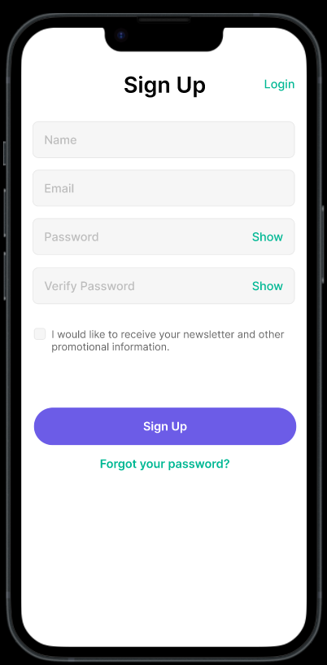

Image Final Sign Up Screens.

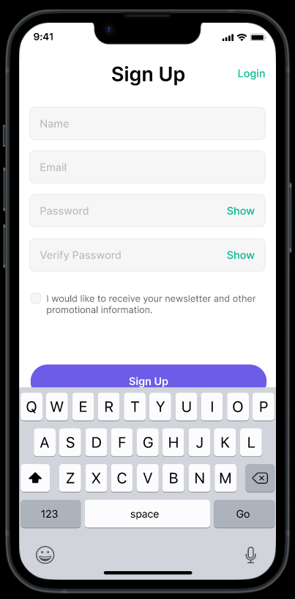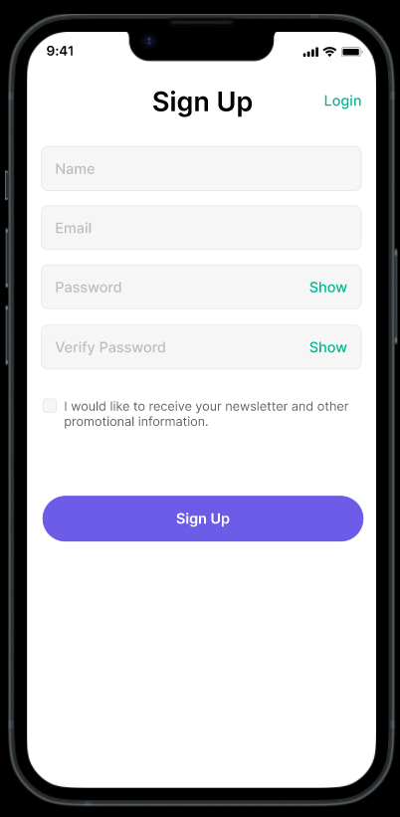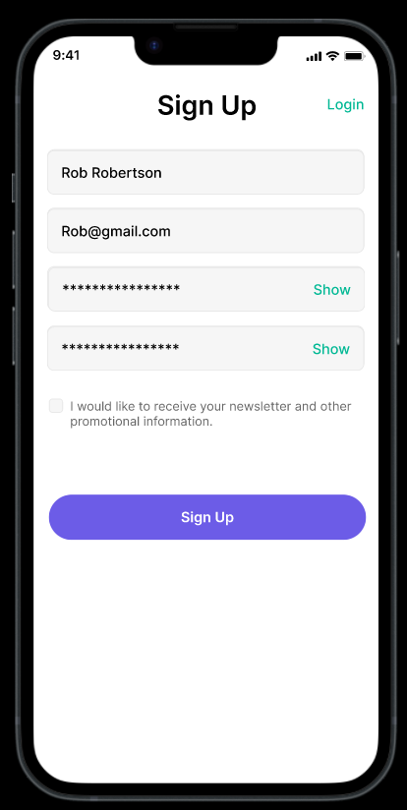

**Sign In Screen**

Image : Sign in screen from final paper prototype

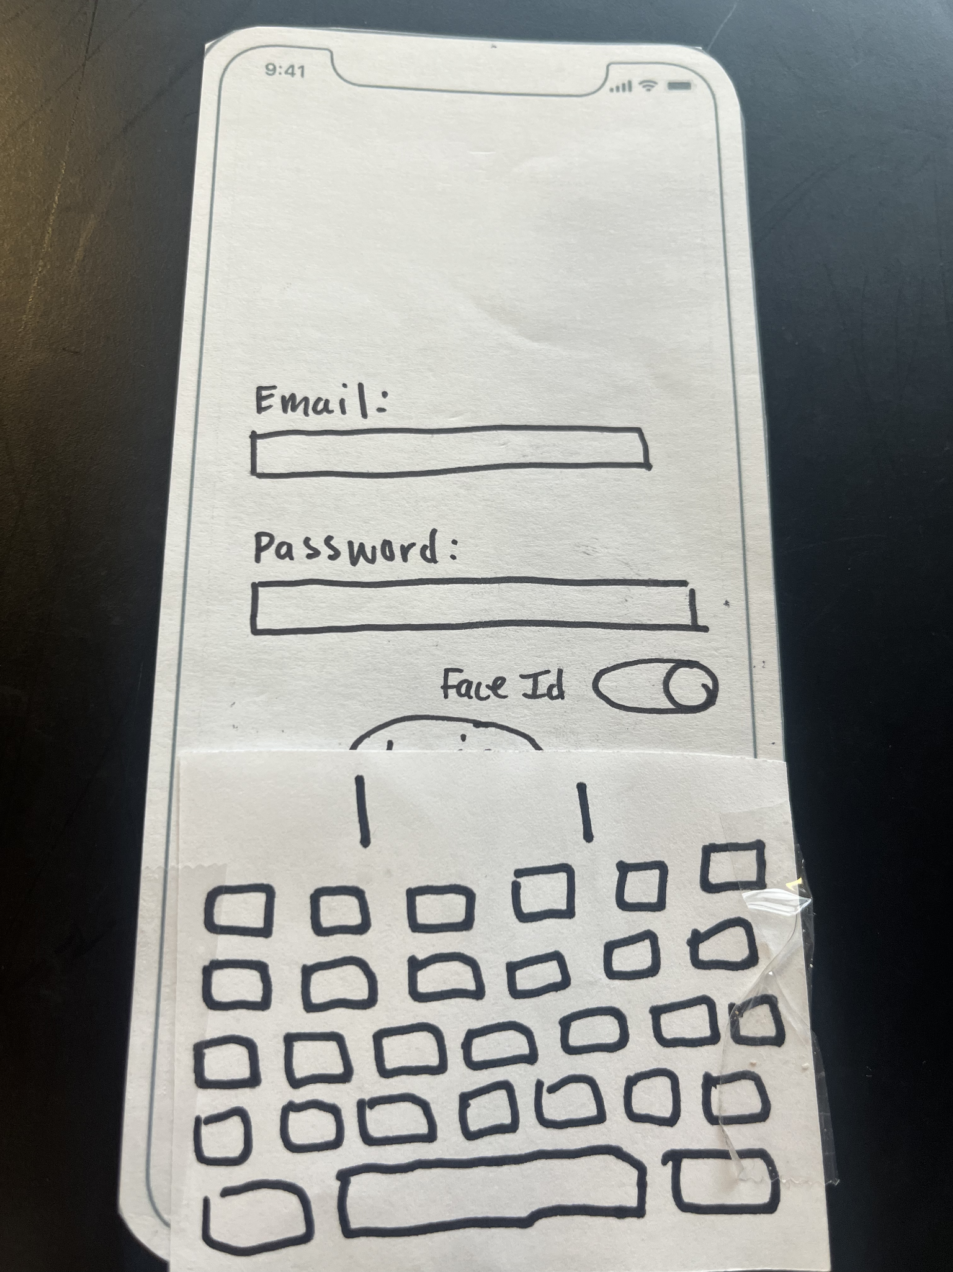

Image : Initial Digital Prototype Log in

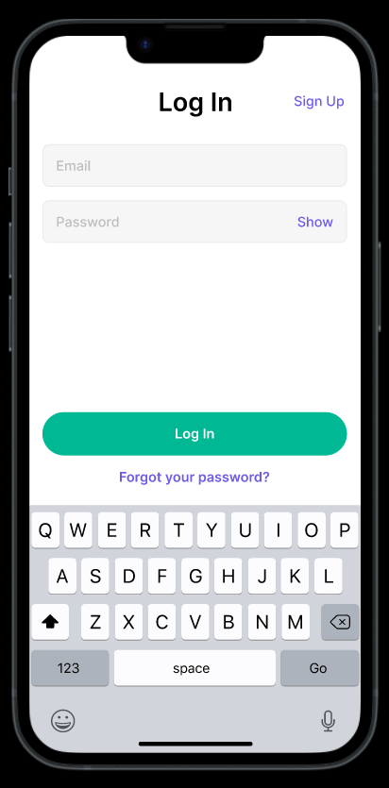

Image : Final digital prototype log in screens

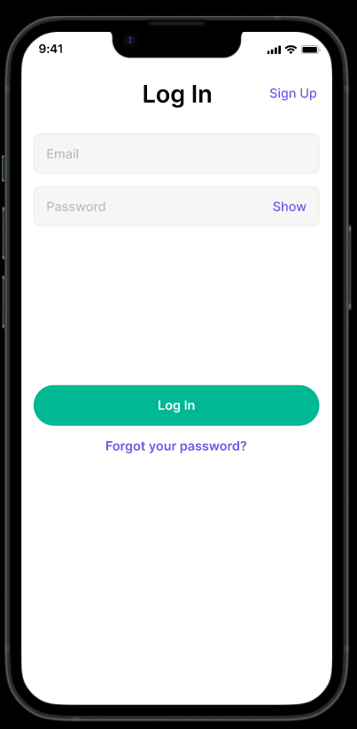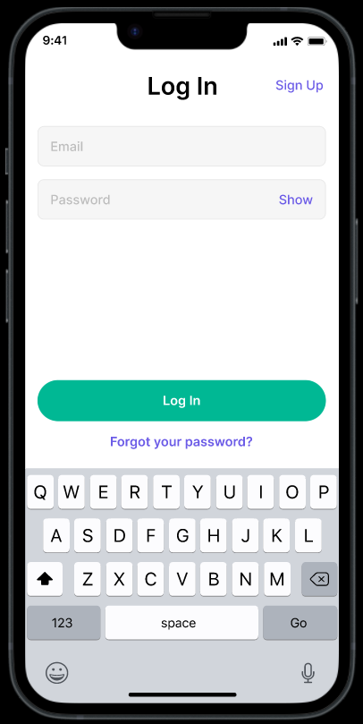

**Start Up Tutorial Page**

Image : Start Up Tutorial page from initial digital mockup.

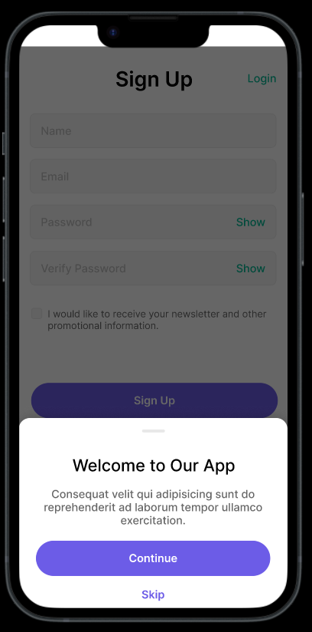

Image : Start Up Tutorial from Final digital mockup

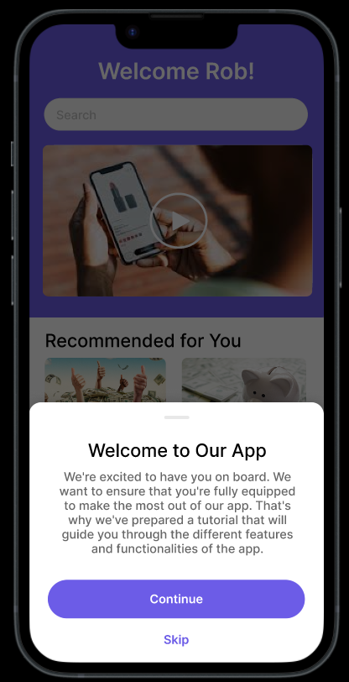

**Home Page**

Image : Home Page Sketch

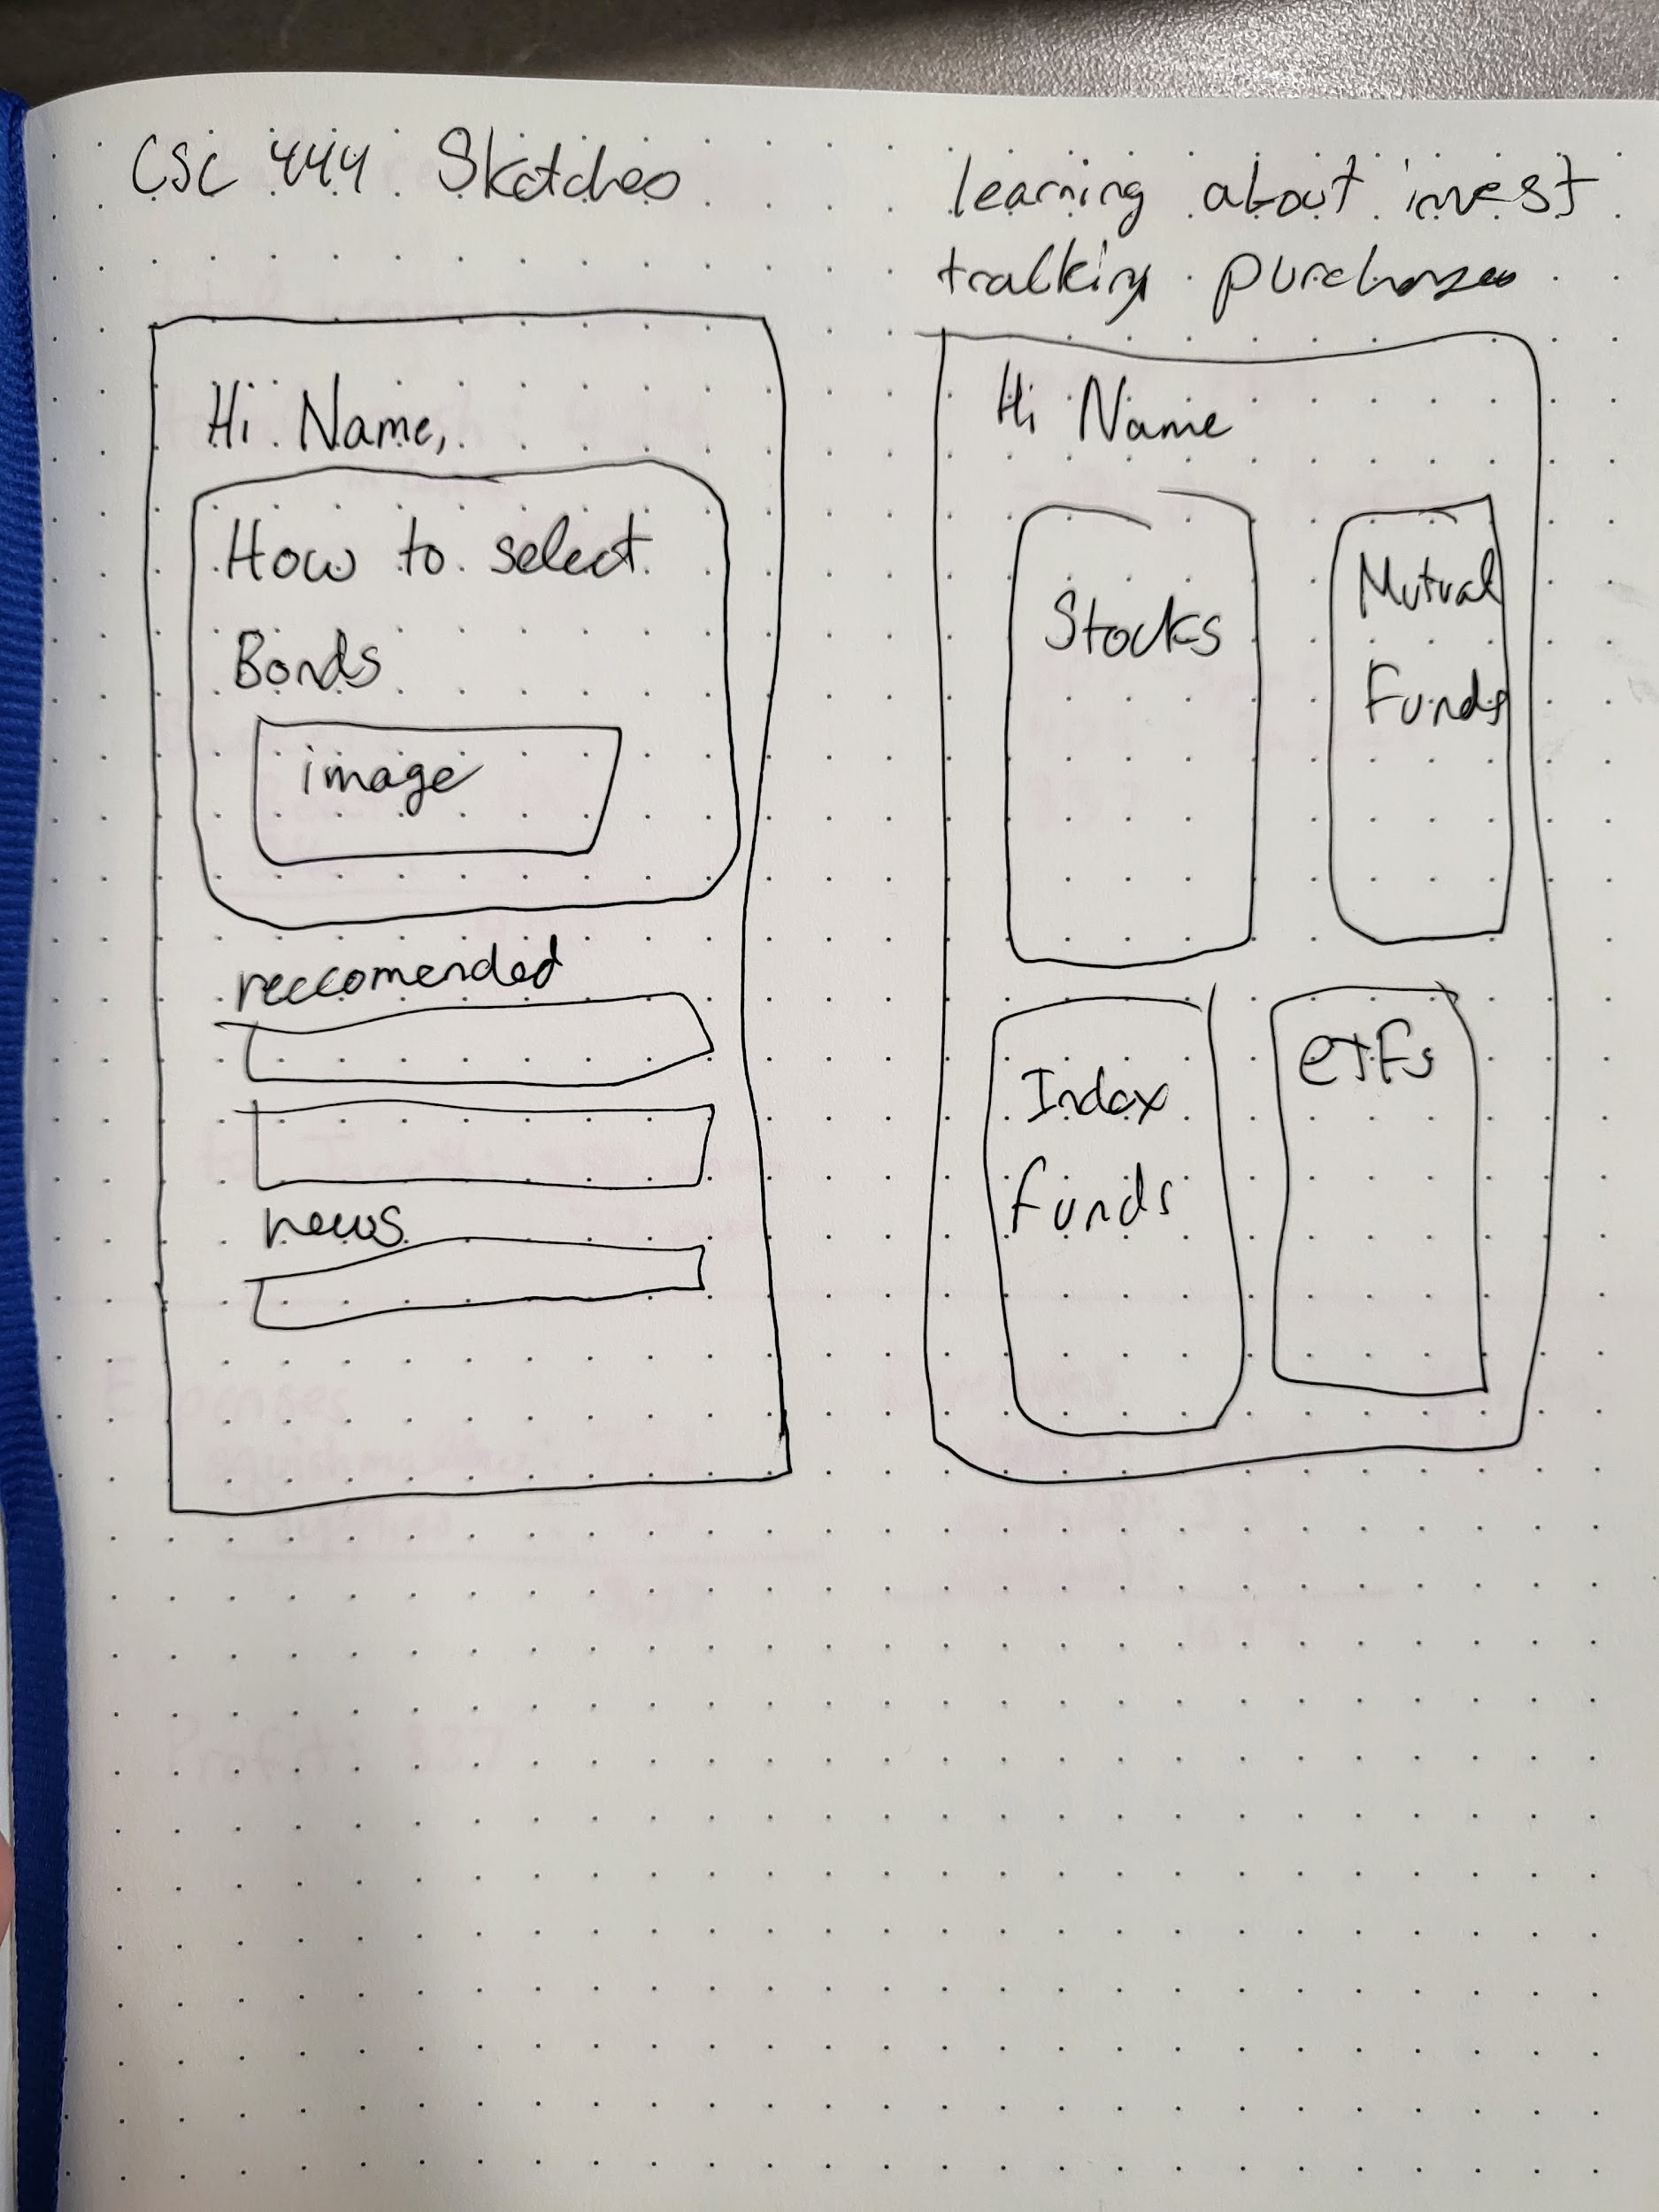

Image : Home Page from final paper prototype

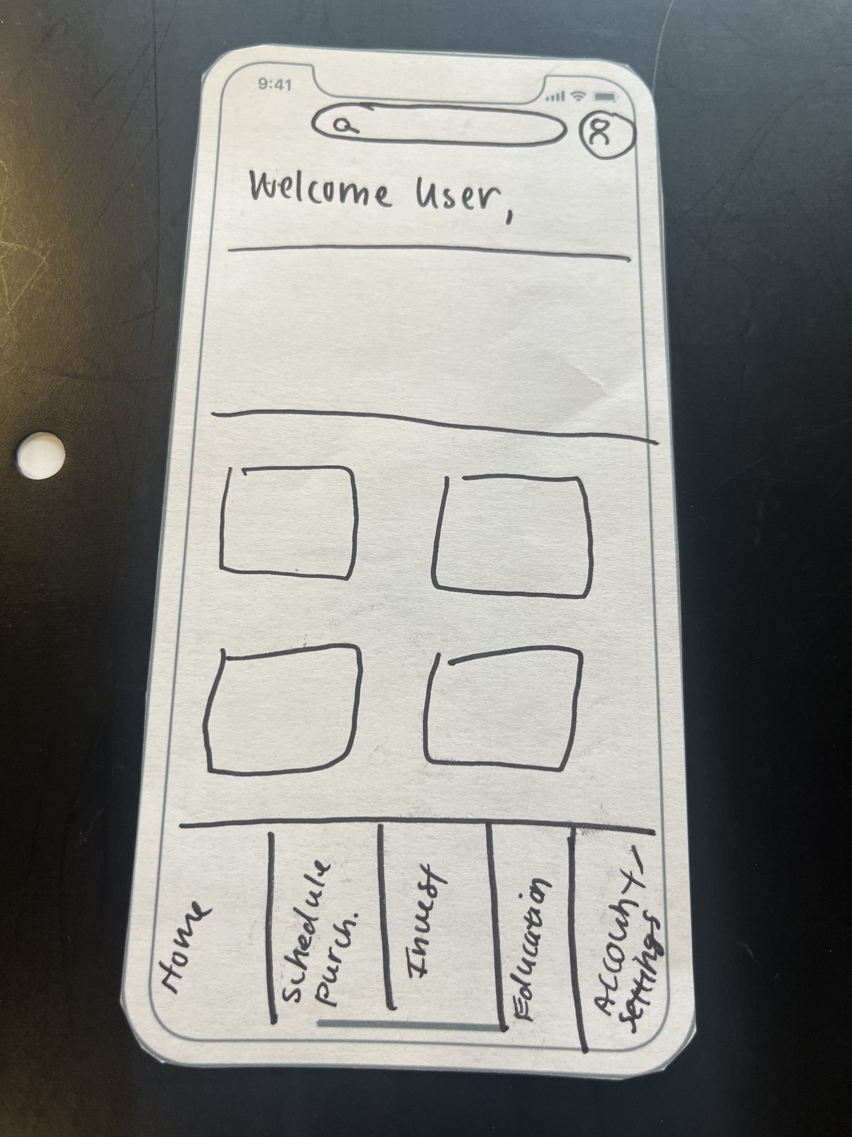

Image : Initial digital mockup home page

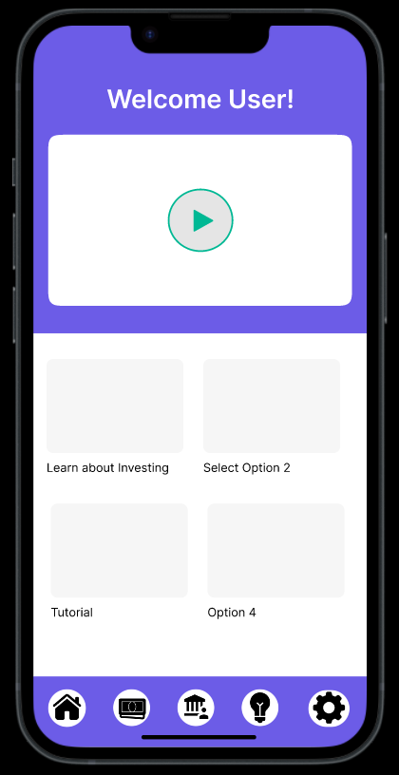

Image : Final Home pages with and without a search bar option

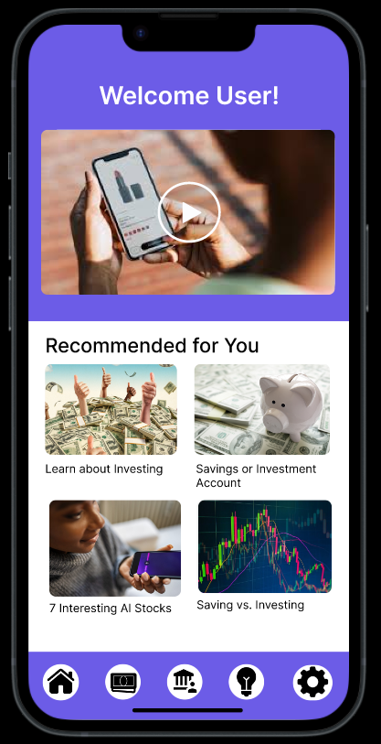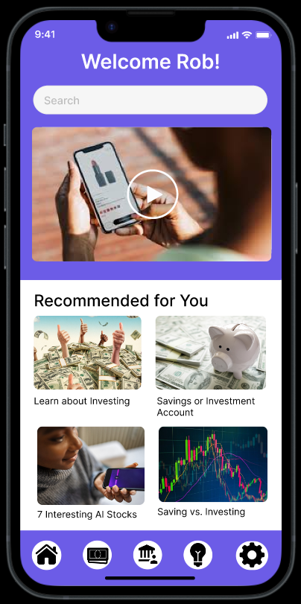

**Search Results Page**

Image : Search Results Page from Final Digital Mockup

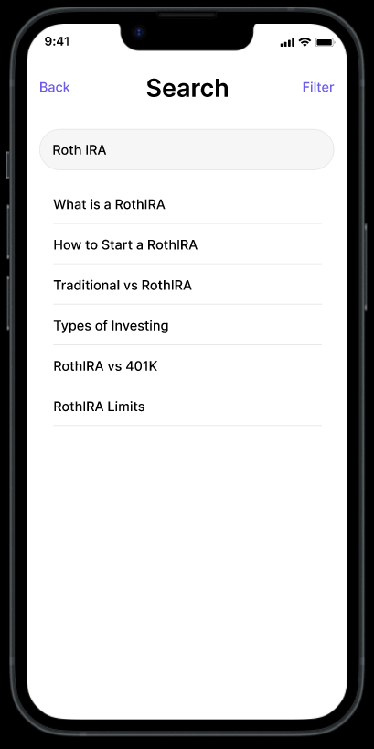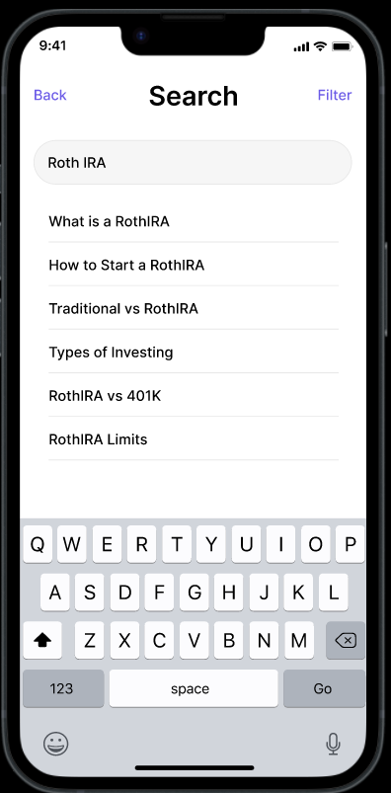

**Filter and Sort Page**

Image : Filter page from initial paper prototype

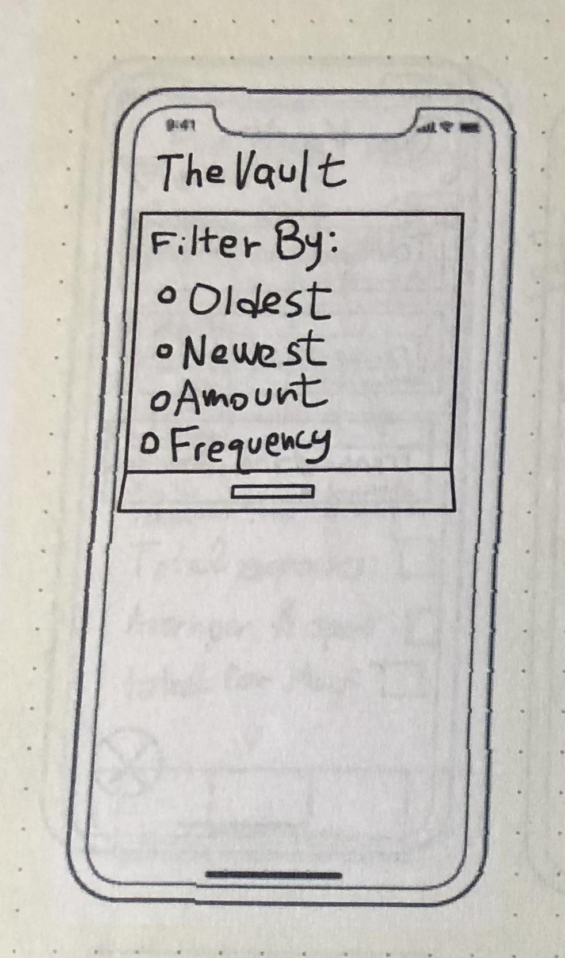

Image : Filter page from Final paper prototype

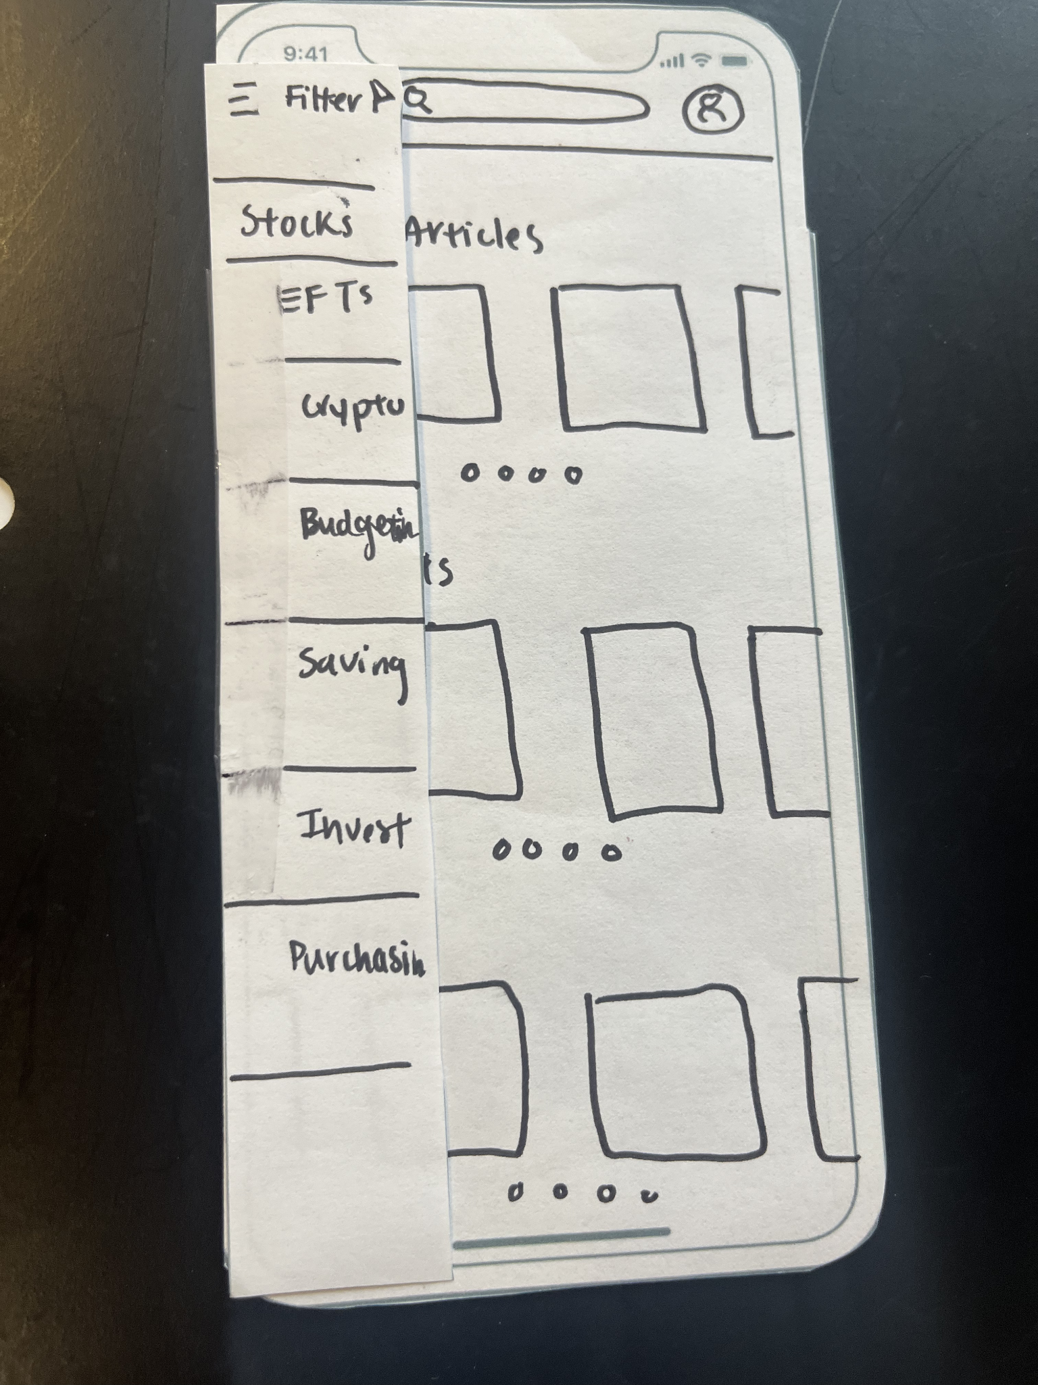

Image : Final Digital Mockup Filter Page

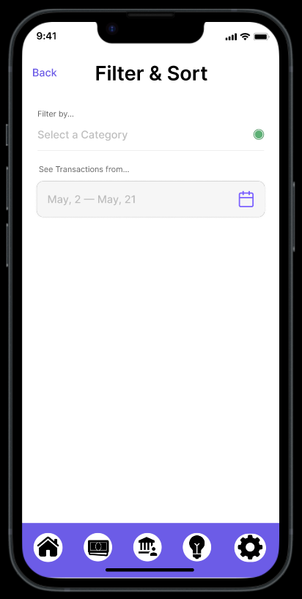

**Education Home Screen**

Image : Education Sketch



Image : Education Initial Paper Prototype

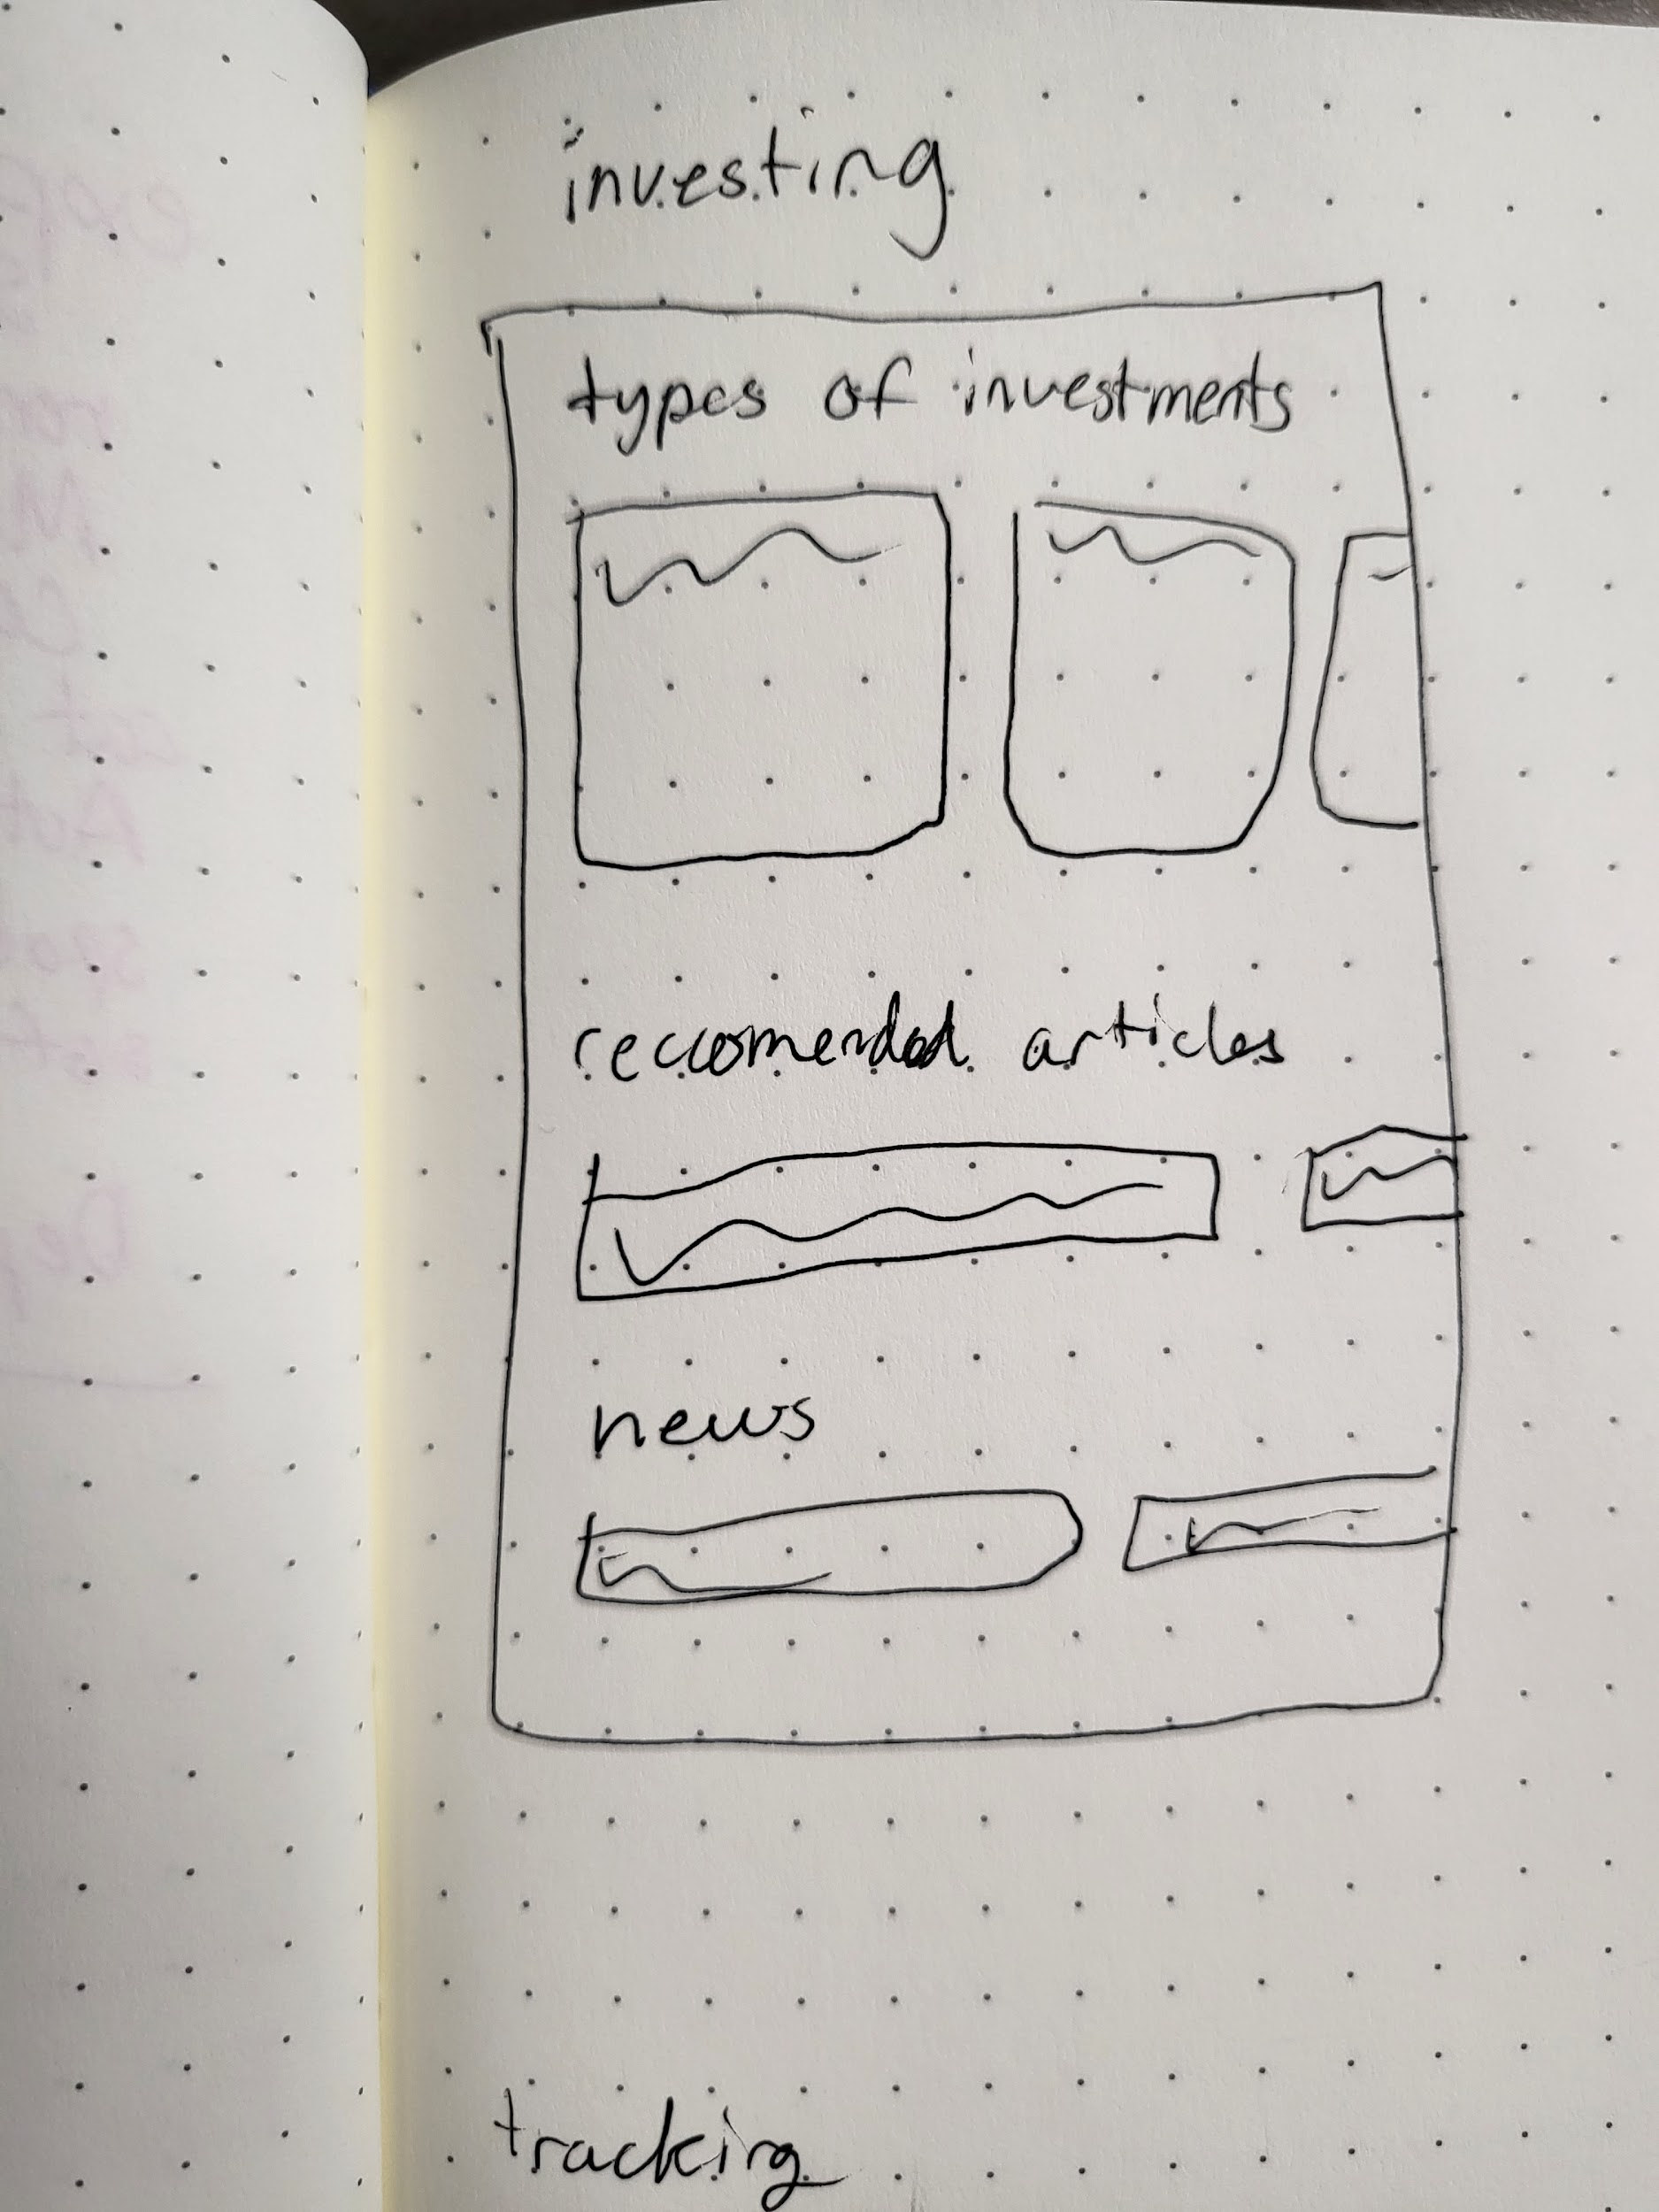

Image : Education Initial Digital Prototype

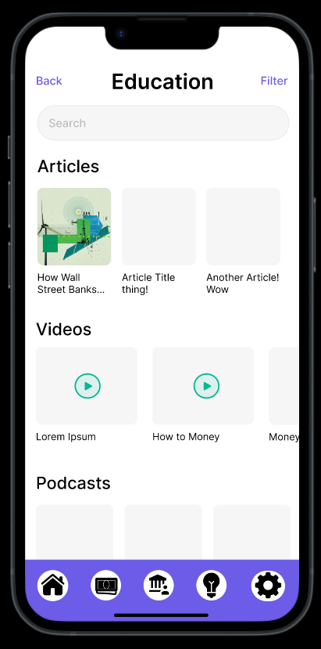

Image : Final Digital Prototype Page

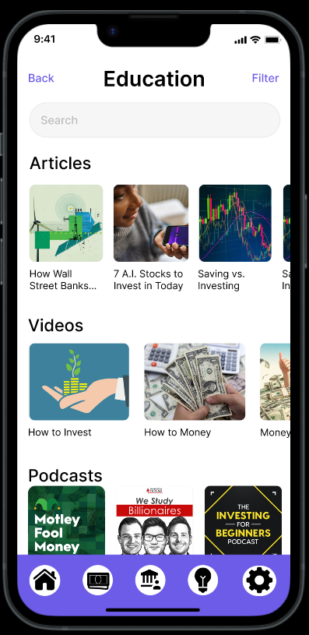

**Video Screen**

Image : Video screen from final paper prototype

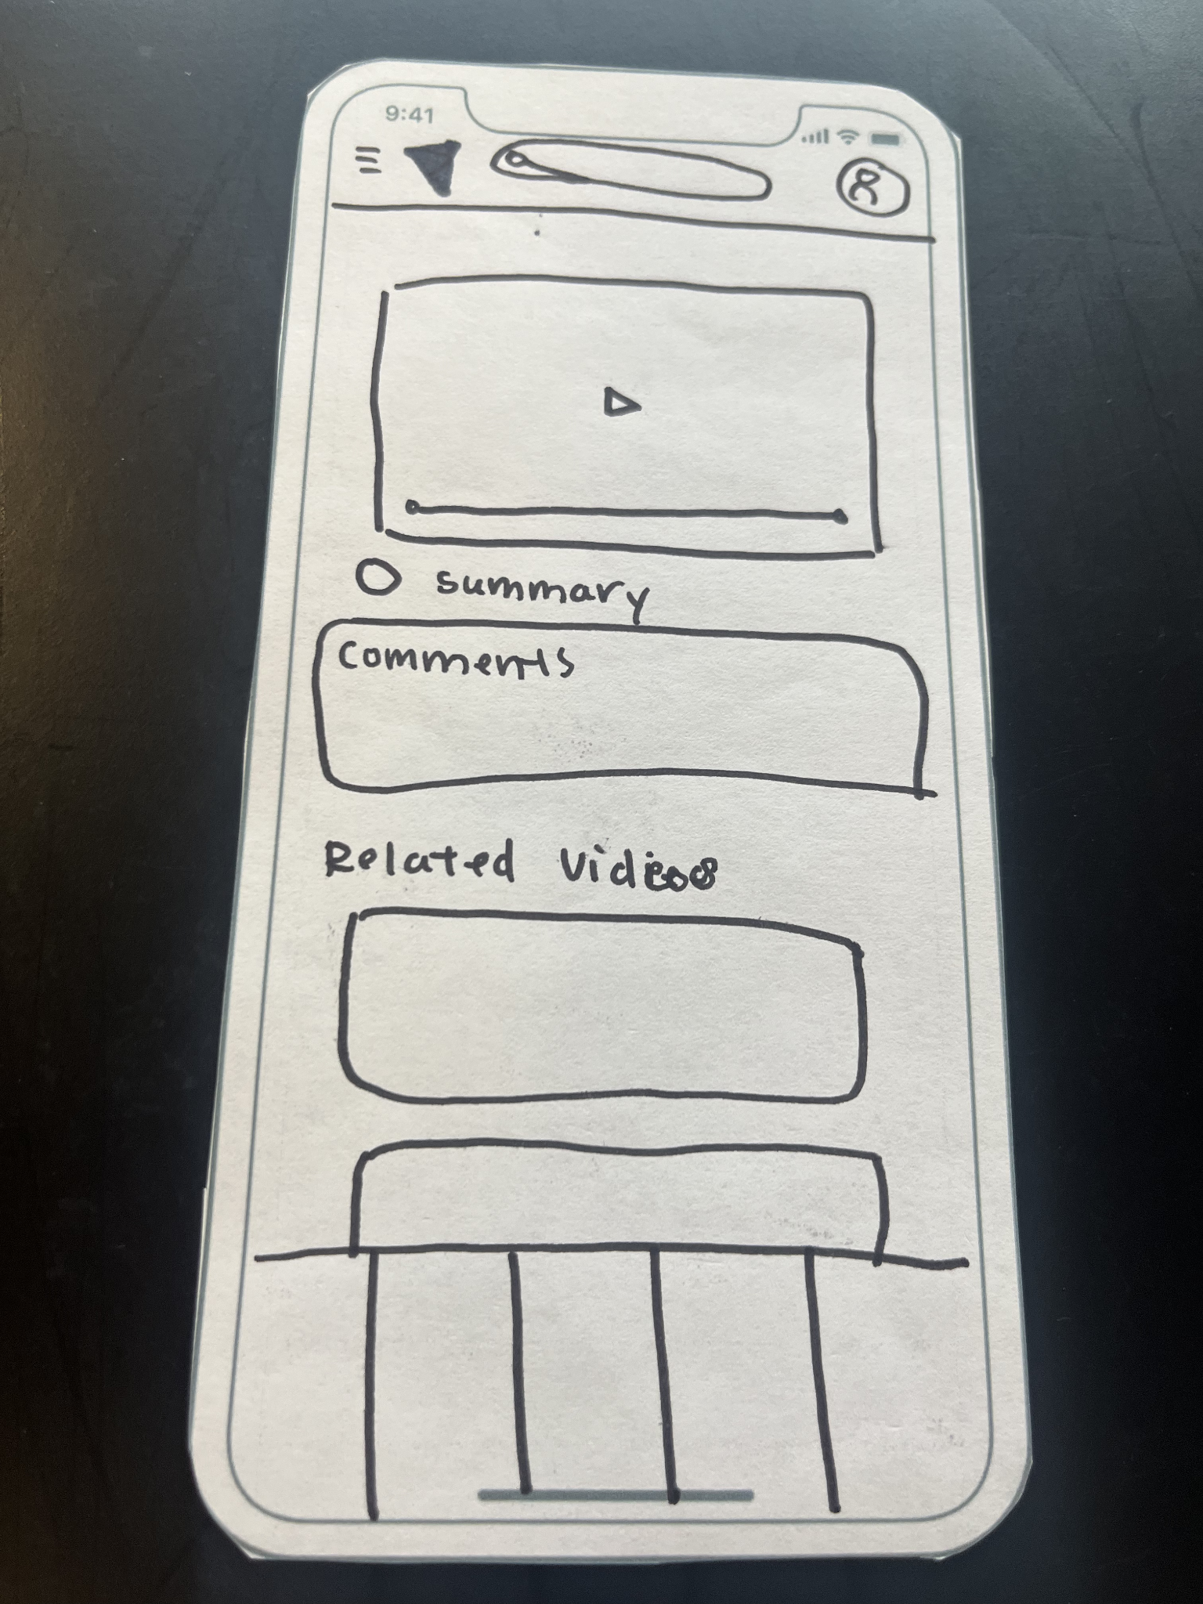

Image : Video Screen from initial digital prototype

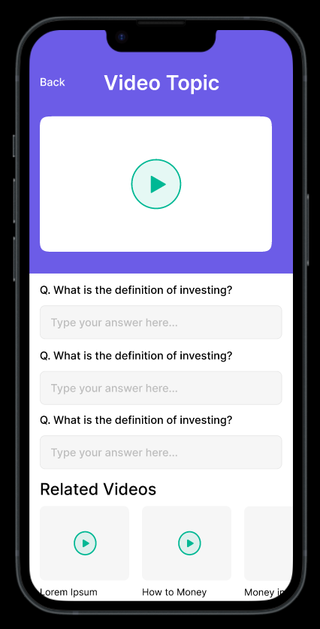

Image : Final digital prototype video screen

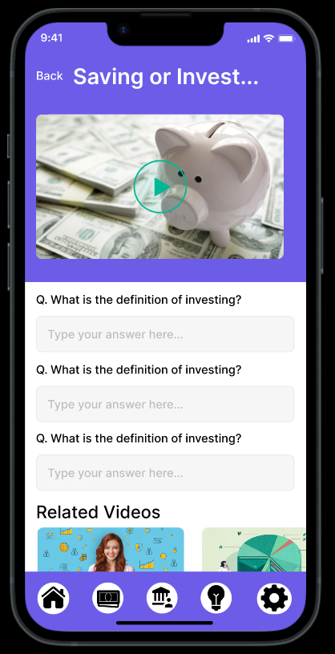

**Video Completion Tutorial Screen:**

Image : Video completion tutorial screen from final digital prototype

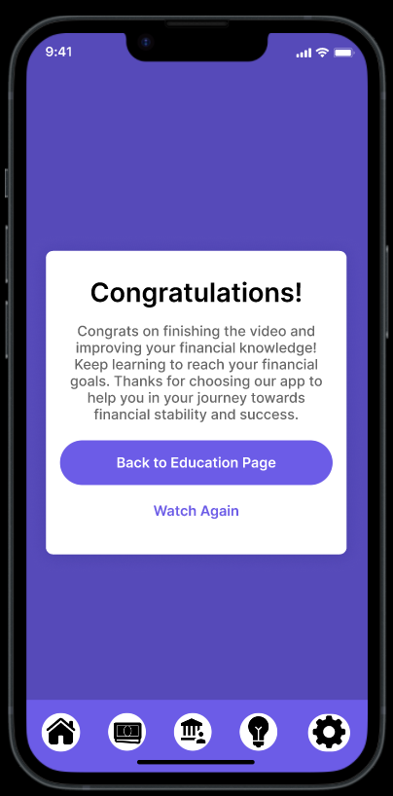

**Article Screen**

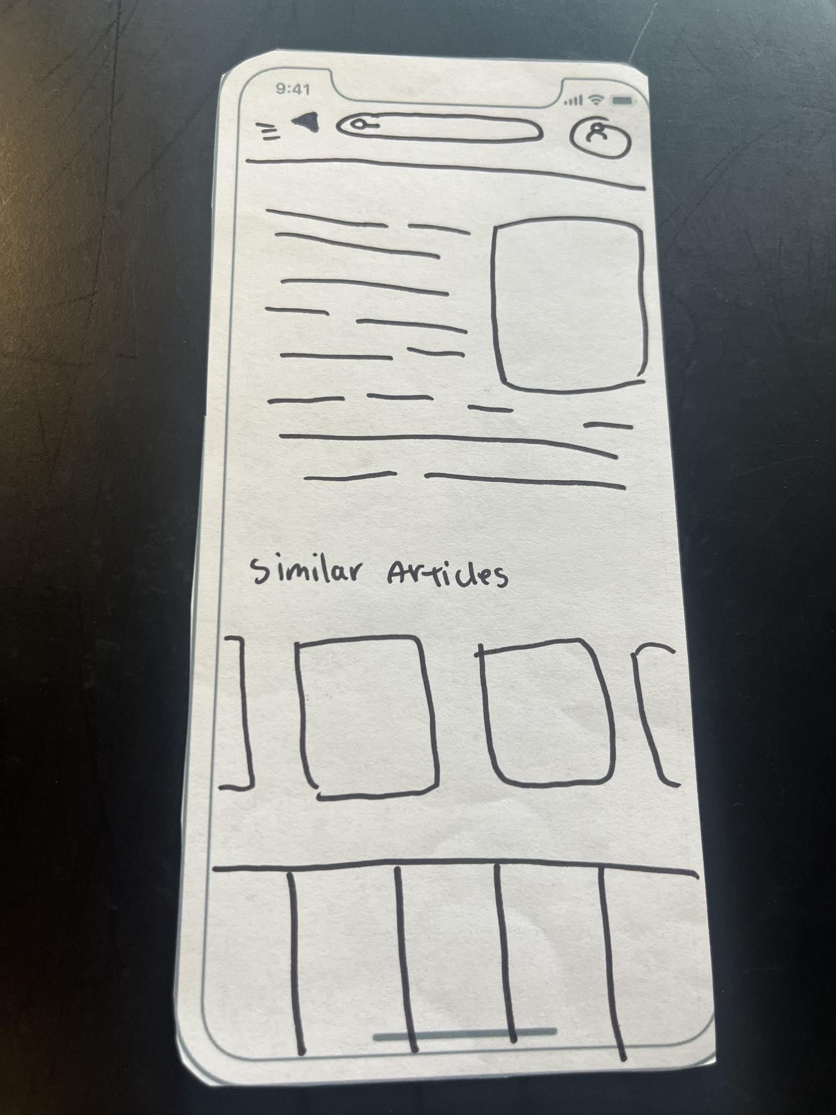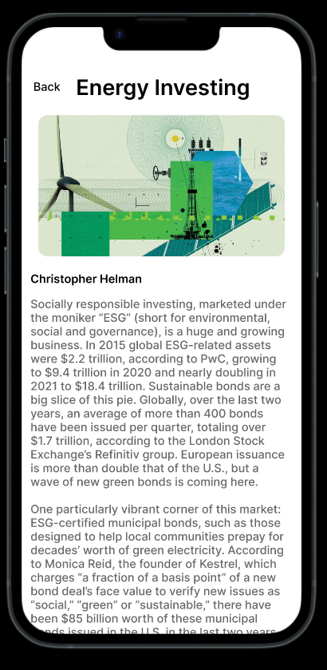

Image : Final Digital Prototype Example Article Pages

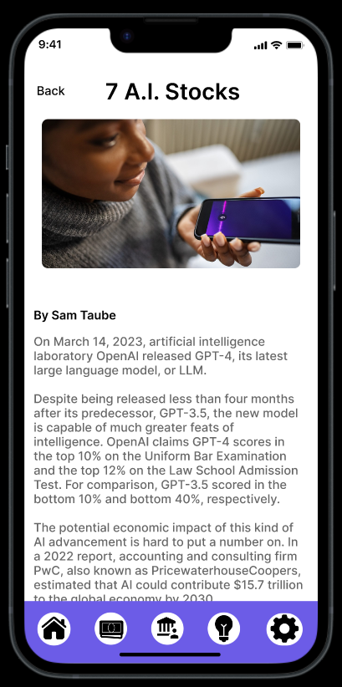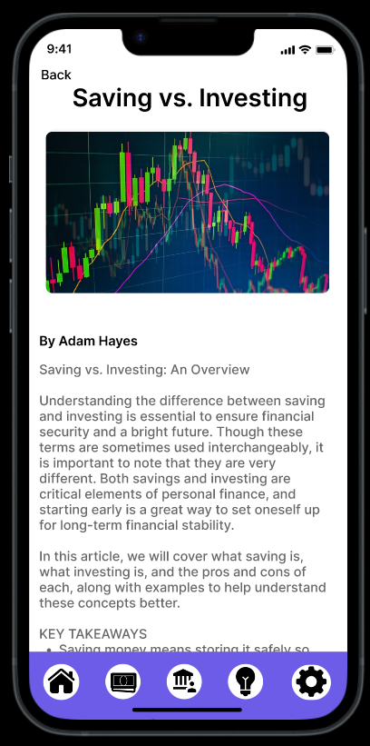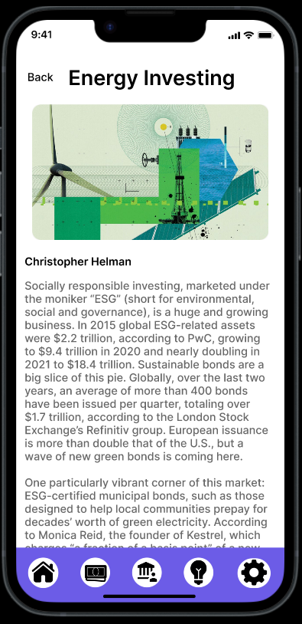

**Podcast Screen**

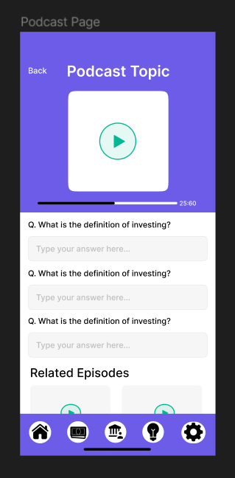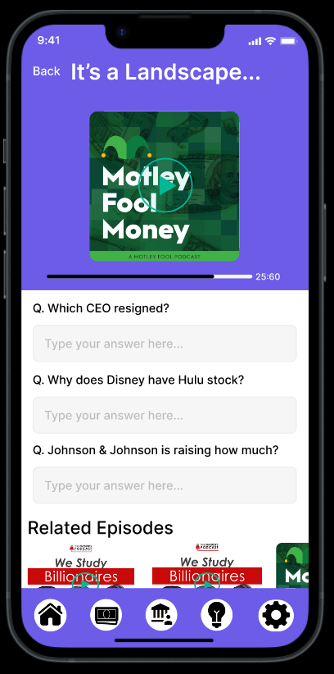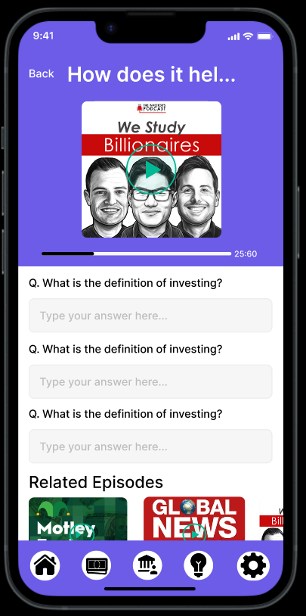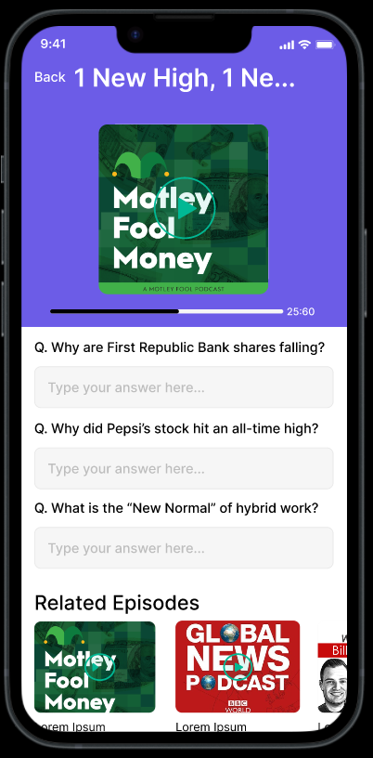

**Purchase History Screen**

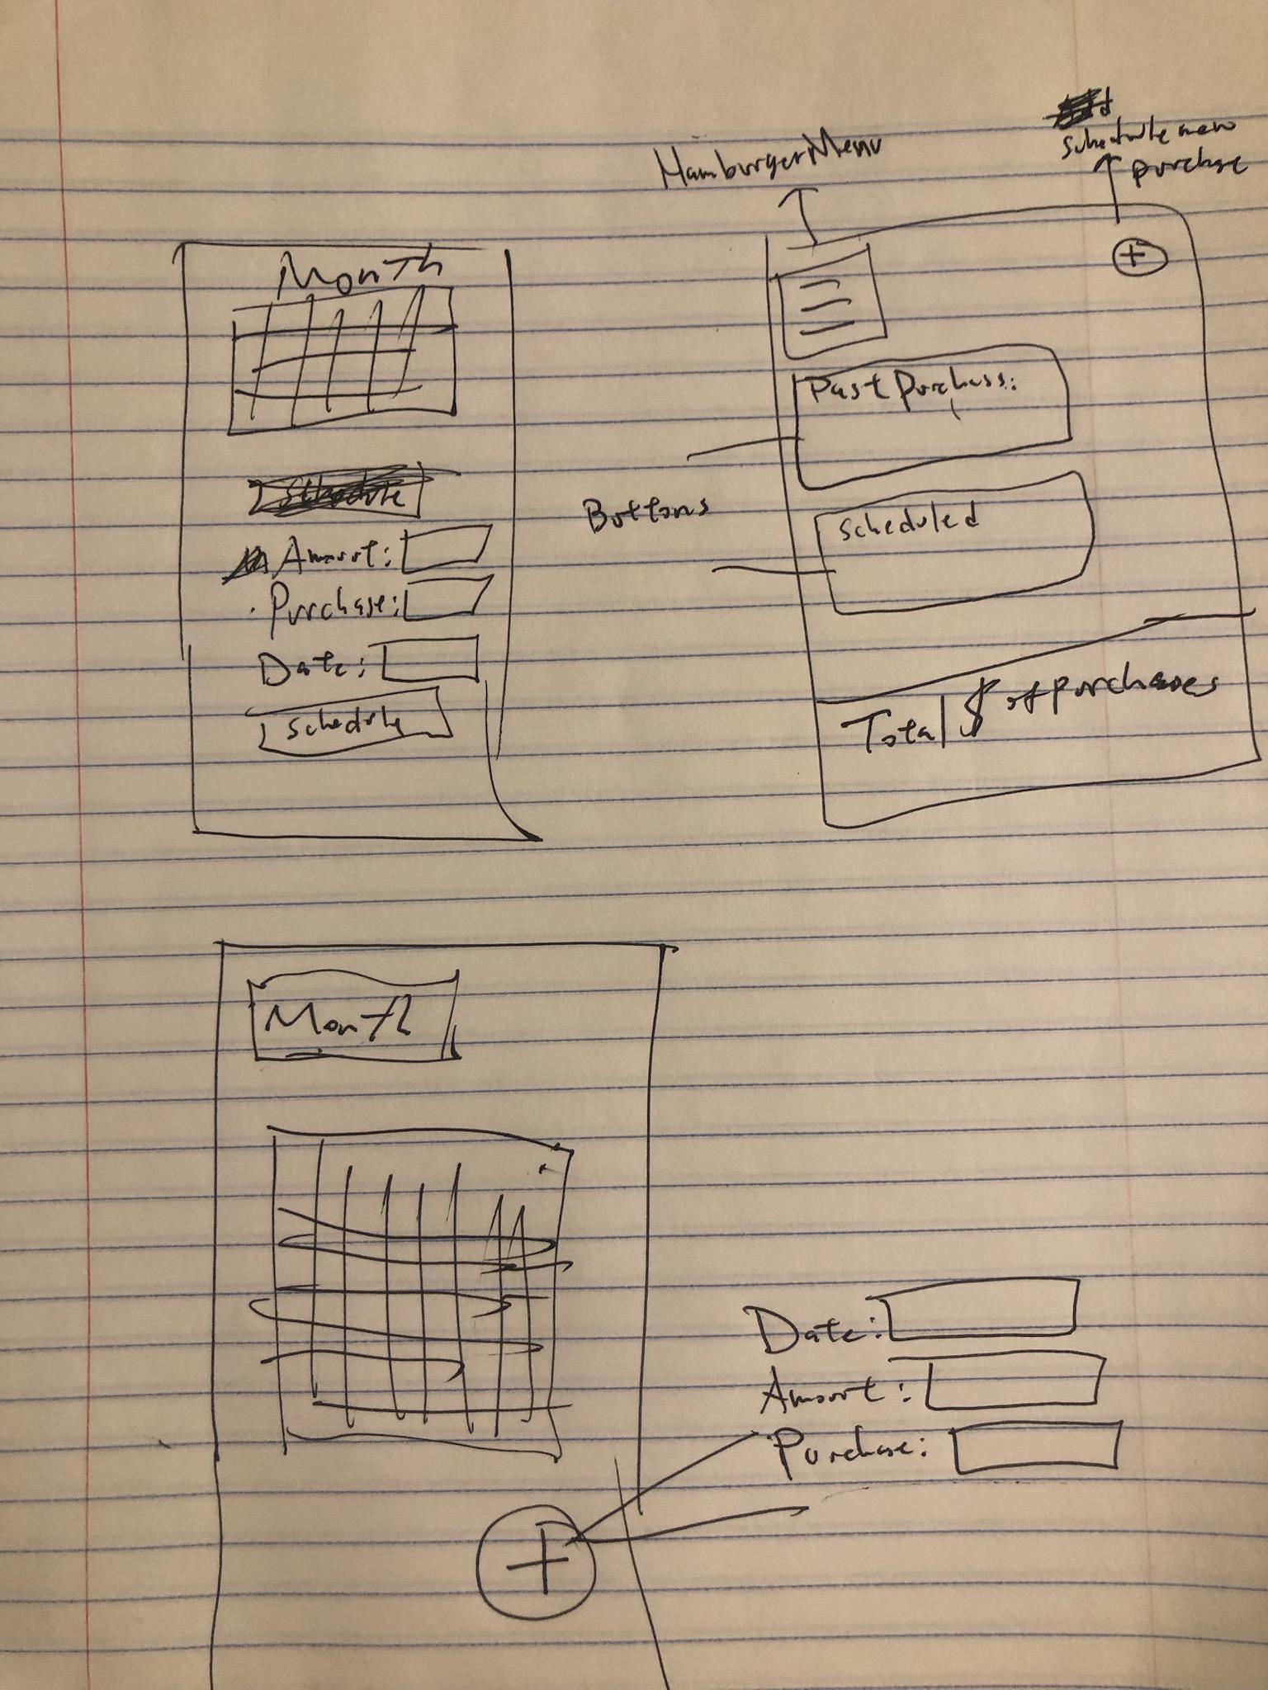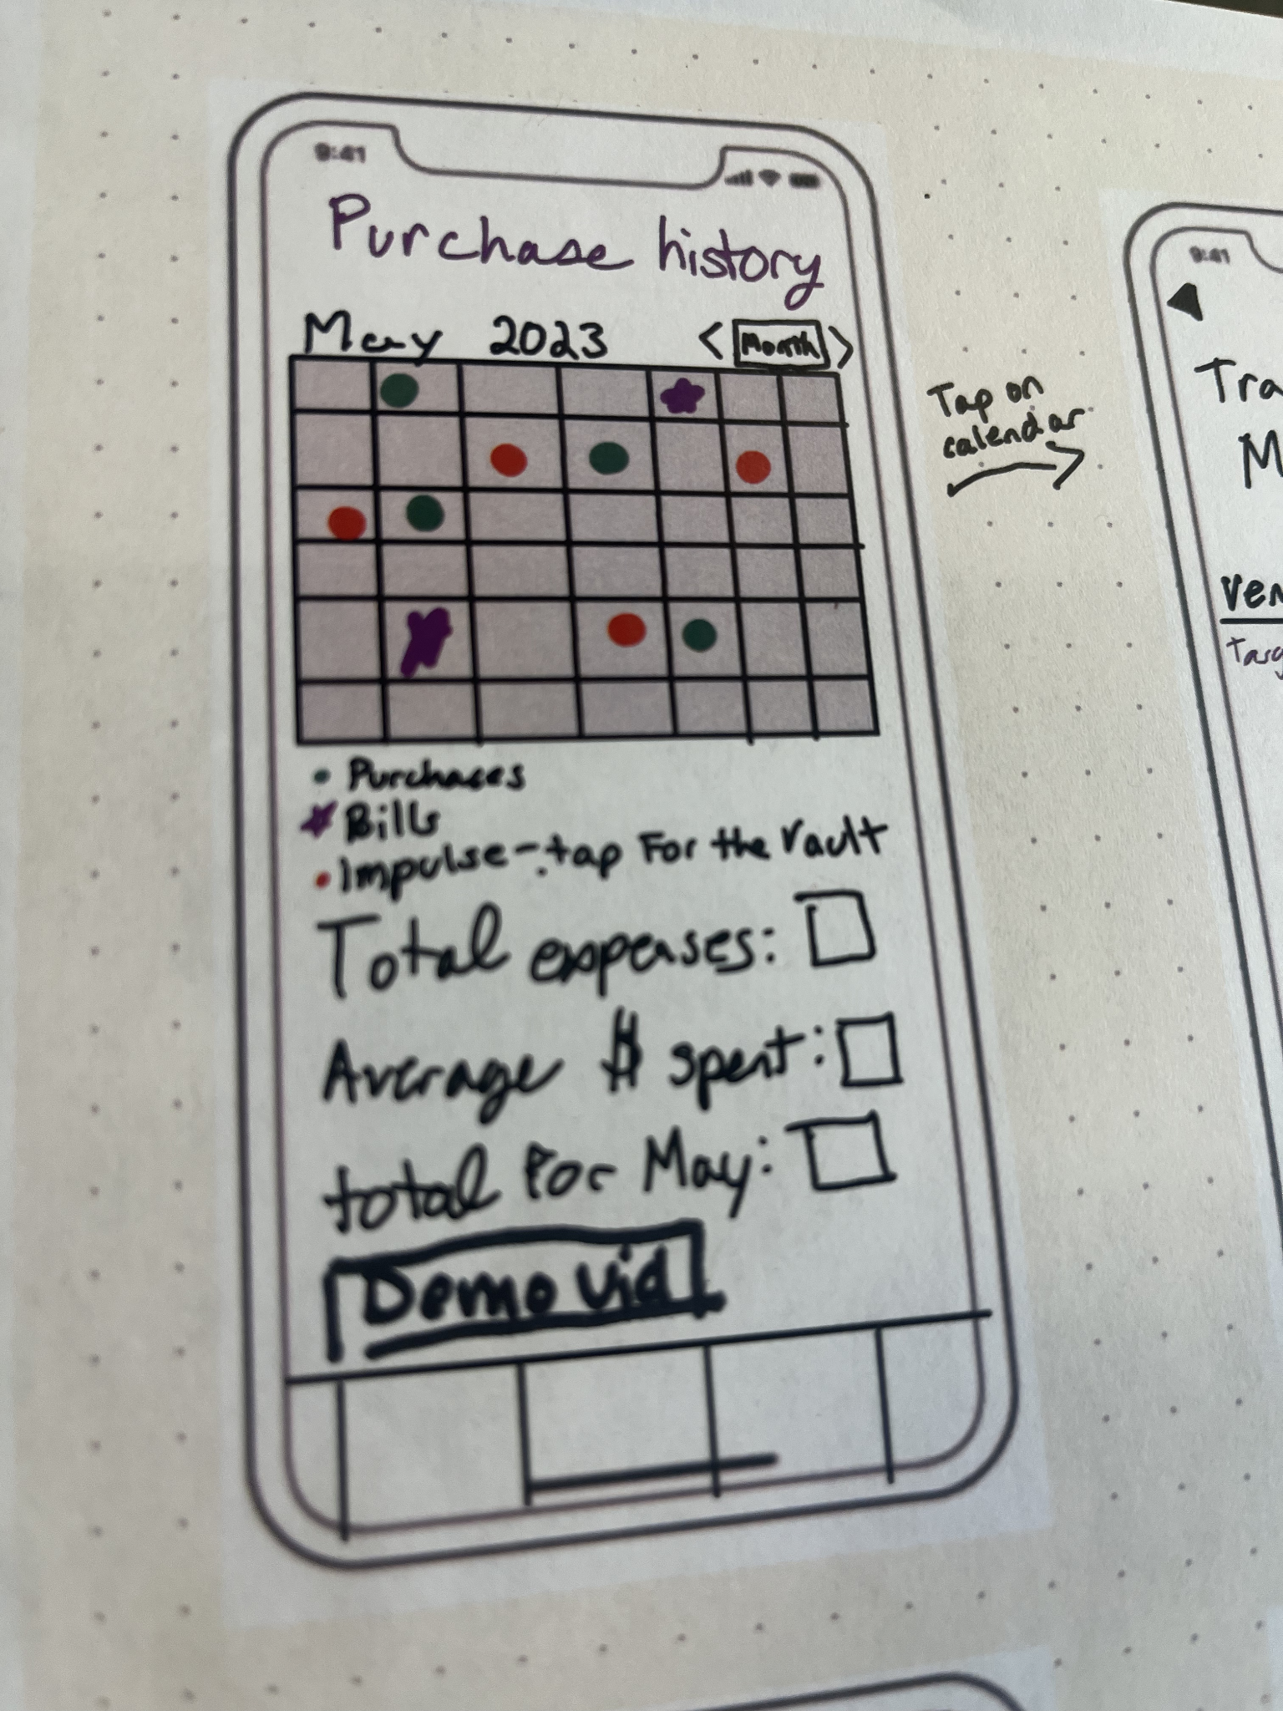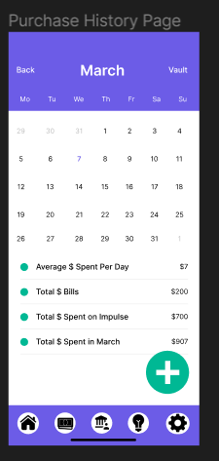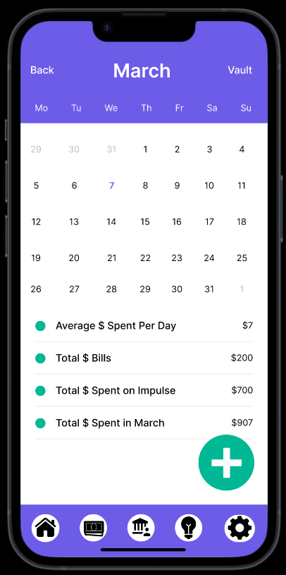

**Purchase History Day Screen**

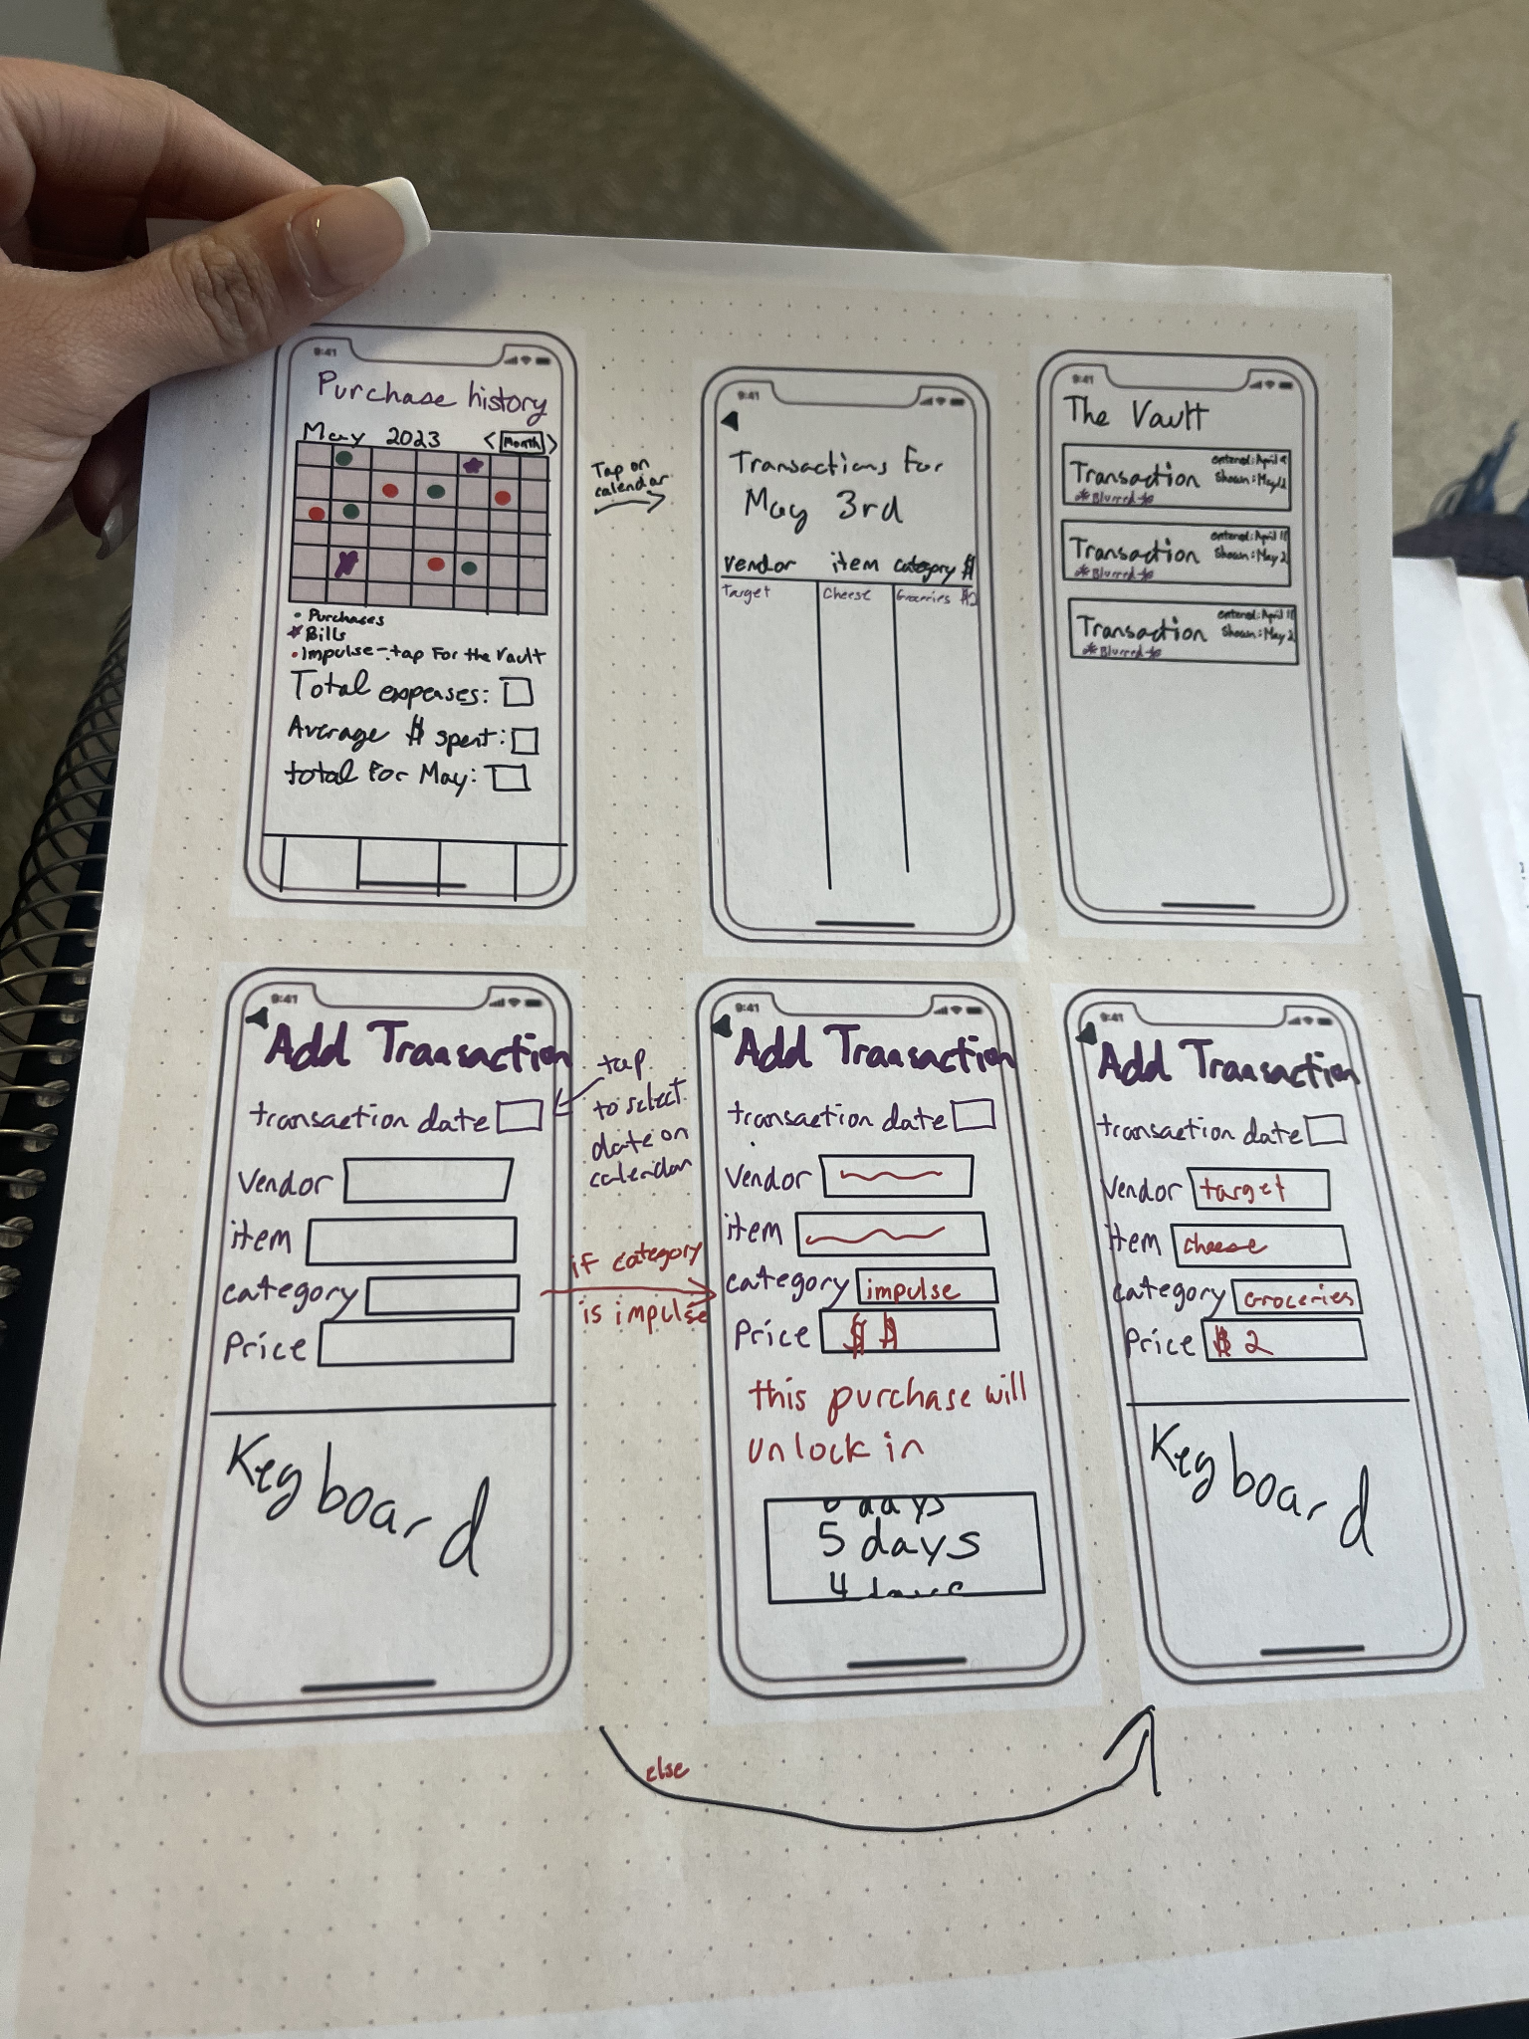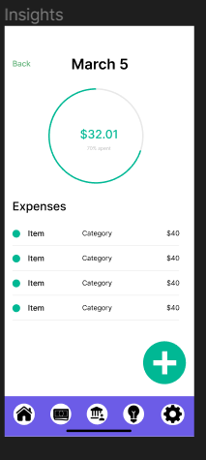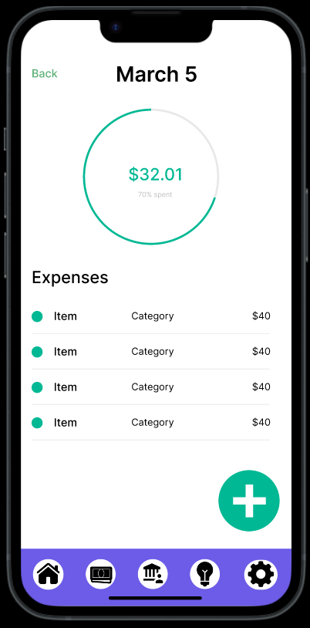

**The Vault**

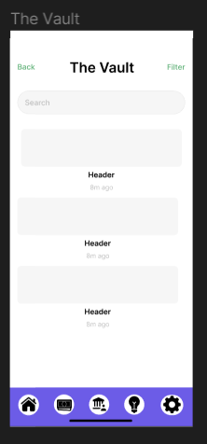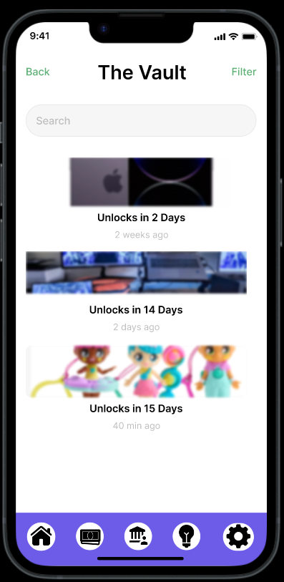

**Add Transaction Screen**

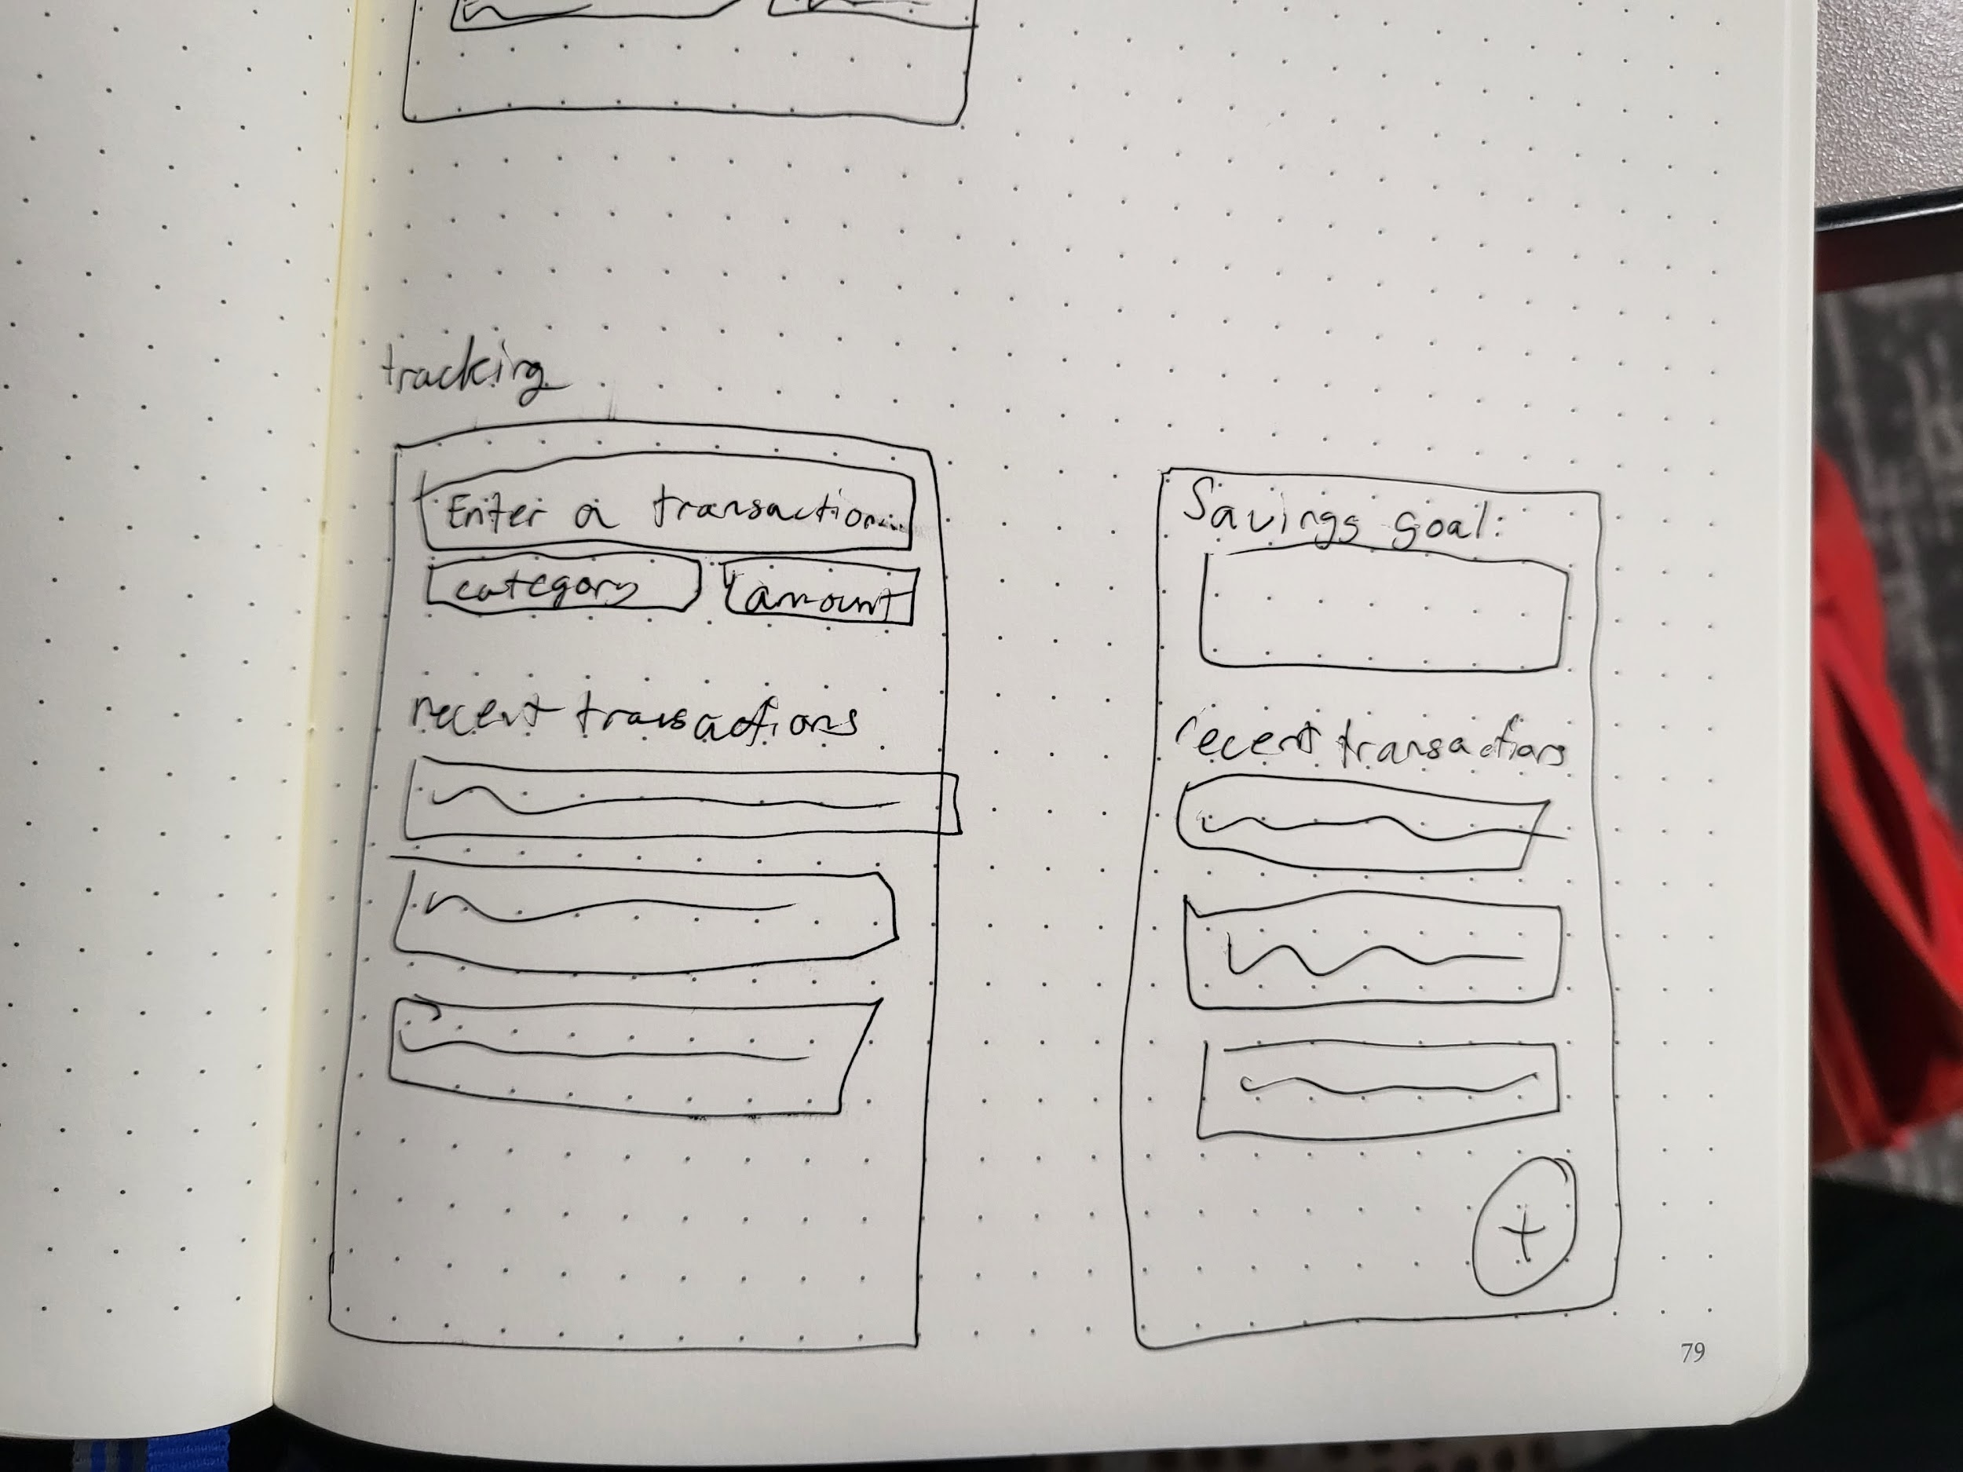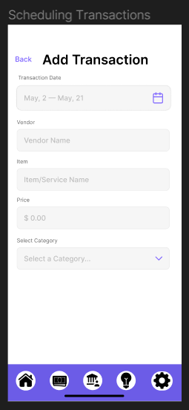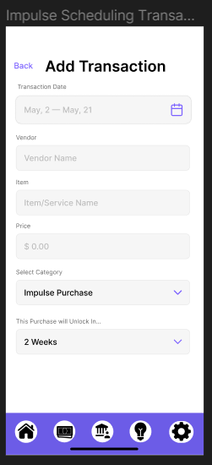

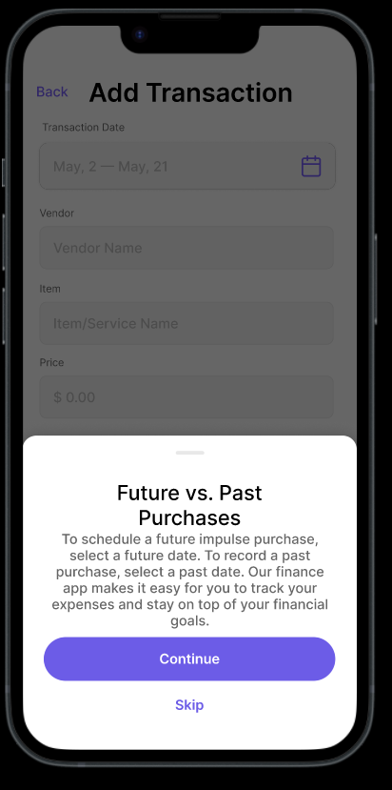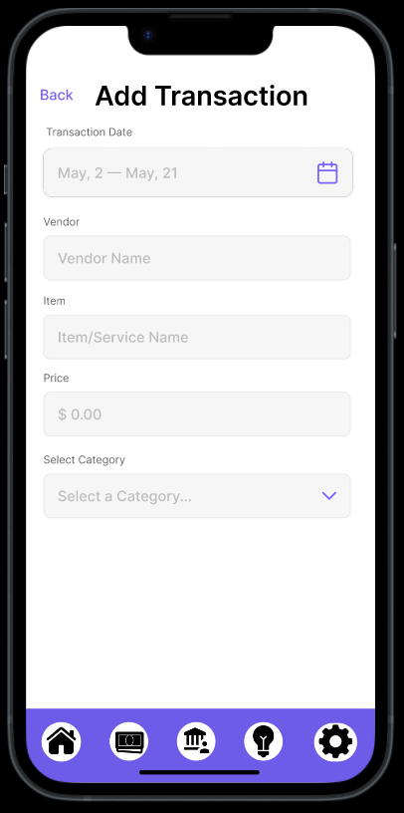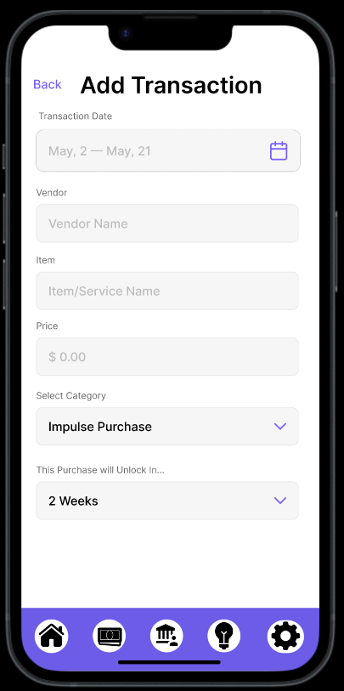

**Investing Home Screen**

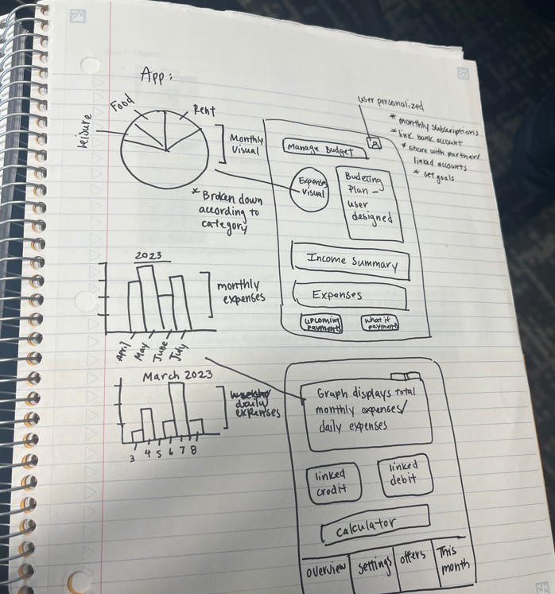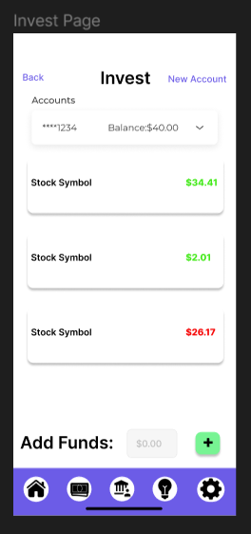

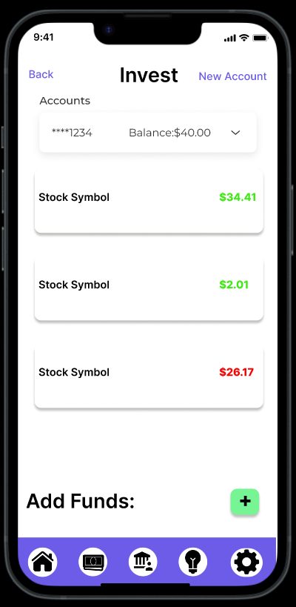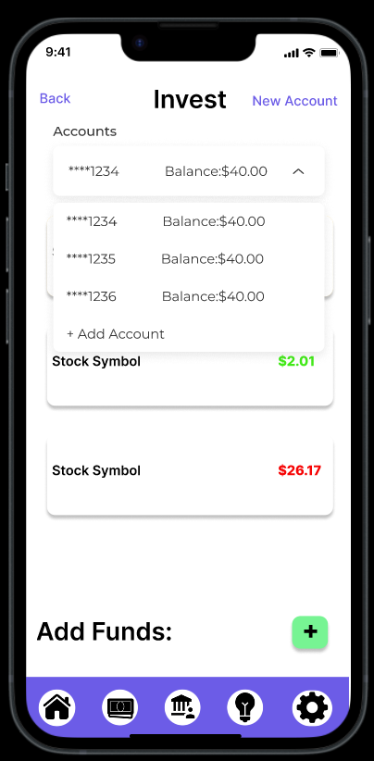

**Stock Information Screen**

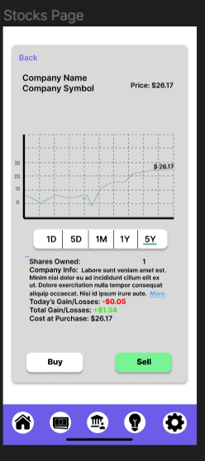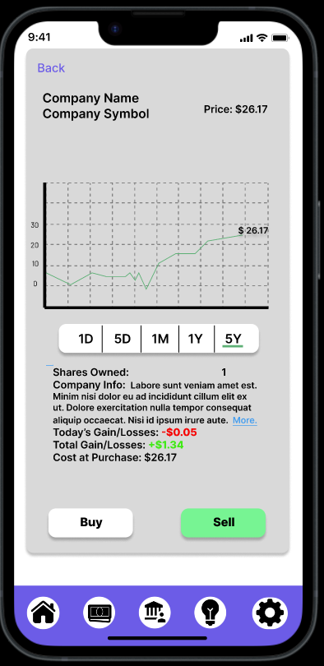

**Investment Account Info Screen**

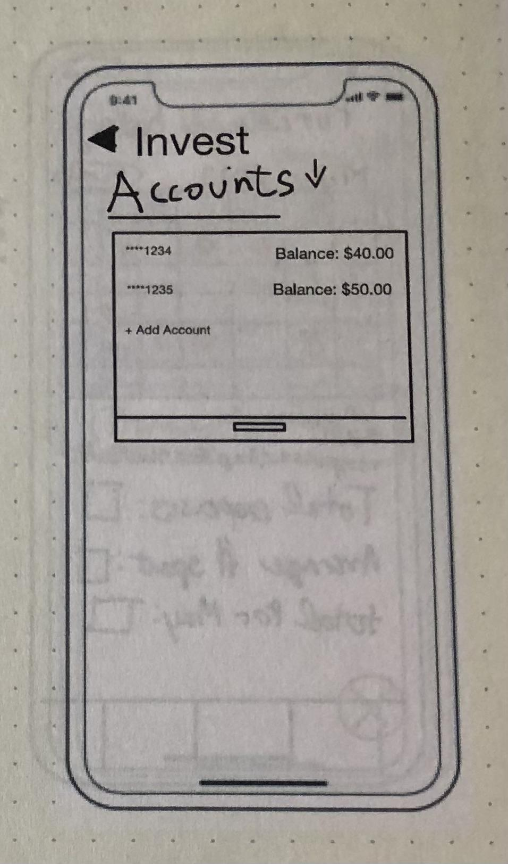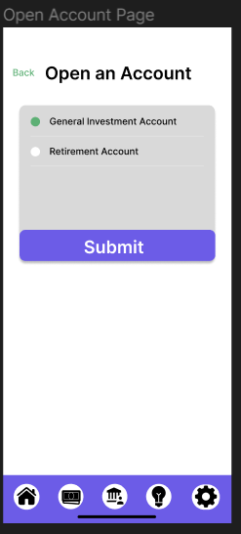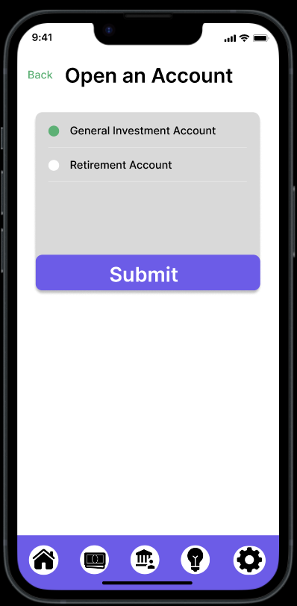

**Settings/Profile Page**

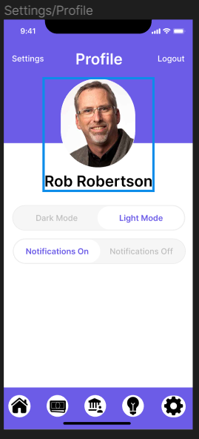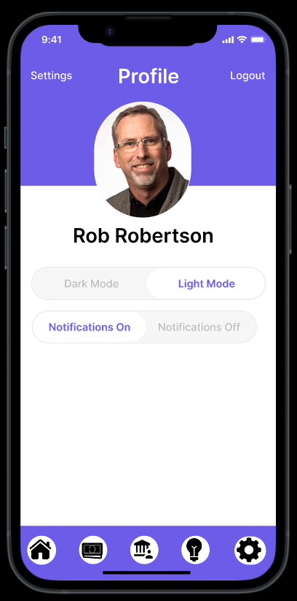

Notes from user interviews:

Notes 1-

· The impulsive purchases tab appears complicated/intimidating at first glance.

o Hard to understand and read.

§ Calendar screen is easy to understand.

§ Emphasize in calendar screen average spent for day

§ Manually inputting everything in is a deterrent *not remembering, keeping receipts—hard to keep track of

o Gamifying the app – increases desire to use app

§ Positive reinforcement

· The application is too diversified.

o The investment section might not be necessary.

o Impulse buying and budgeting goes together well.

· Purchase will unlock.

o Change to a timer – unlock implies its locked

o No notifications for the vault

§ Maybe a subtle check mark to indicate unlocked

· Categories

o Should include the option to include your own categories

§ Differentiate between needs and impulses

· Customizing

o Being able to customize—might unlock different color palettes or stickers to further customize.

§ Incentives you to customize the app

· Having required tutorials/education before being able to use the app